Chatter

Sep 1
Going forward articles will include a comments section. No login is required at this stage as the traffic volume is expected to be low. Comments are generally welcome. I get some email feedback on my articles, the vast majority of which is quite value adding. It seems to me that in many cases that feedback would often do more good being in a comment for others to read.

Aug 23
ITK’s price forecasts are coming soonish.

Aug 7
Updating some previous numbers the going rate for a 6 MW wind turbine seems about $60k per year. So the 54 turbines of Doughboy windfarm that 9 landowners turned down is about $3.2 m or $97 m over 30 years. Lots of money to give up for any reason. Things must be good in the bush although my understanding 6/9 potential hosts weren’t even residents.

19 July
Whitehaven reported coal production costs of A$114/t. Price received for NSW thermal coal of US$137/t (A$210/t). That’s likely for top quality thermal coal (26 gj/t) but even so translating that back to NSW coal generation for say Eraring gives 9.5 GJ/MWh * 210 / 26 = $76/MWh fuel cost.

8 Jun 24 78
Am emerging leading light in understanding social cohesion and division in the transition is Associate Professor Rebecca Colvin.
“So, for instance, quite a bit of research has shown that Australia is the second most polarised country on climate change along left-right political lines, with the US being the most polarised country.”
100climateconversations
A topical quote considering todays headlines that the LNP is more or less turning its back on Paris commitments.

5 Jun 24
A reminder tha there are 20 GW of wind and solar operating
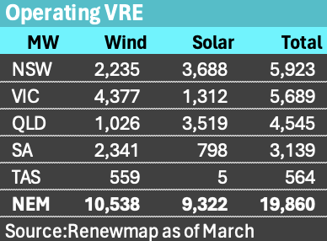
And the total is set to grow 30% based on projects under construction, although Rye Park 400 MW wind could now be regarded as operating reducing the growth rate.
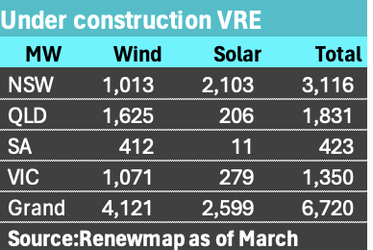

3 Jun 24

CIS scheme webinar
- Not a lot of real news but well attended plenty of Q&A. In response to my question about will it get new capacity built there seems to be a general focus rather than specific provisions. Ie choosing projects that are capable and will be built. Comes down to who is doing the administering.
- Focus on getting the right number of bidders as the assement process will take months, and too many will slow it down.

2 Jun 24

Renewmap is the go
renewmap is the best new site to open in 2024. Great map based coverage of esxising, being constructed and proposed generation

Binsted Chair NSW Energyco
As announced here Paul Binsted, Chair of Stanwell has been appointed Chairpoers onf the Board of the Energy Corporation of NSW. CEO is Paul Hay.

