Neosmelt

David Leitch

2025-06-10

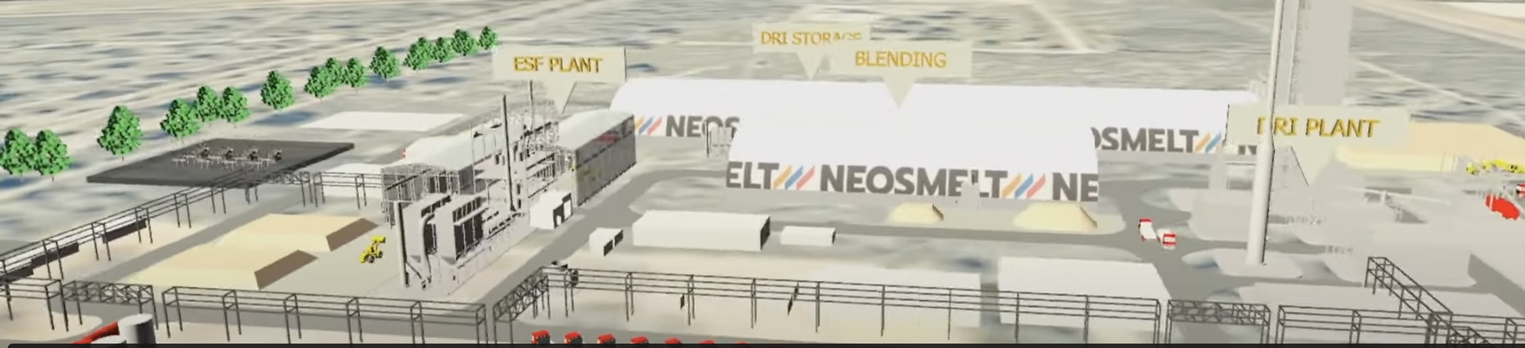

Neosmelt concept. Source:Bluescope

## NeoSmelt - Steel makers are taking it seriously in Australia

I didn’t realise how far the process of an ESF had progressed in Australia. Although a final investment decision(FID ) wont be made until 2026 and even the feasibility decisions won’t be made until Q2 2025, the interesting news is that BHP RIO and Bluescope have formed a consortium with the plan to build a 30,000 to 40,000 tonne per year ESF facility. More recently for reasons best known to the other participants Woodside has joined the consortium. I want to say at the outset that the consortium cannot be improved by having Woodside included. It pretty much means that the partners wont be aligned but nevertheless.

$75 m of funding has been provided by the WA Govt. However the project has yet to reach FID so it’s not a rapid journey. Stegra is far advanced.

30-40 kt is small of course relative to Australia’s total iron ore exports of close to 900 million tons but its never the less a big investment

Its worth watching the Youtube of the [announcement](https://www.youtube.com/watch?v=HrsIDh7r3Qo&t=129s)