Stegra
David Leitch
2025-06-10

In pictures taken from the website
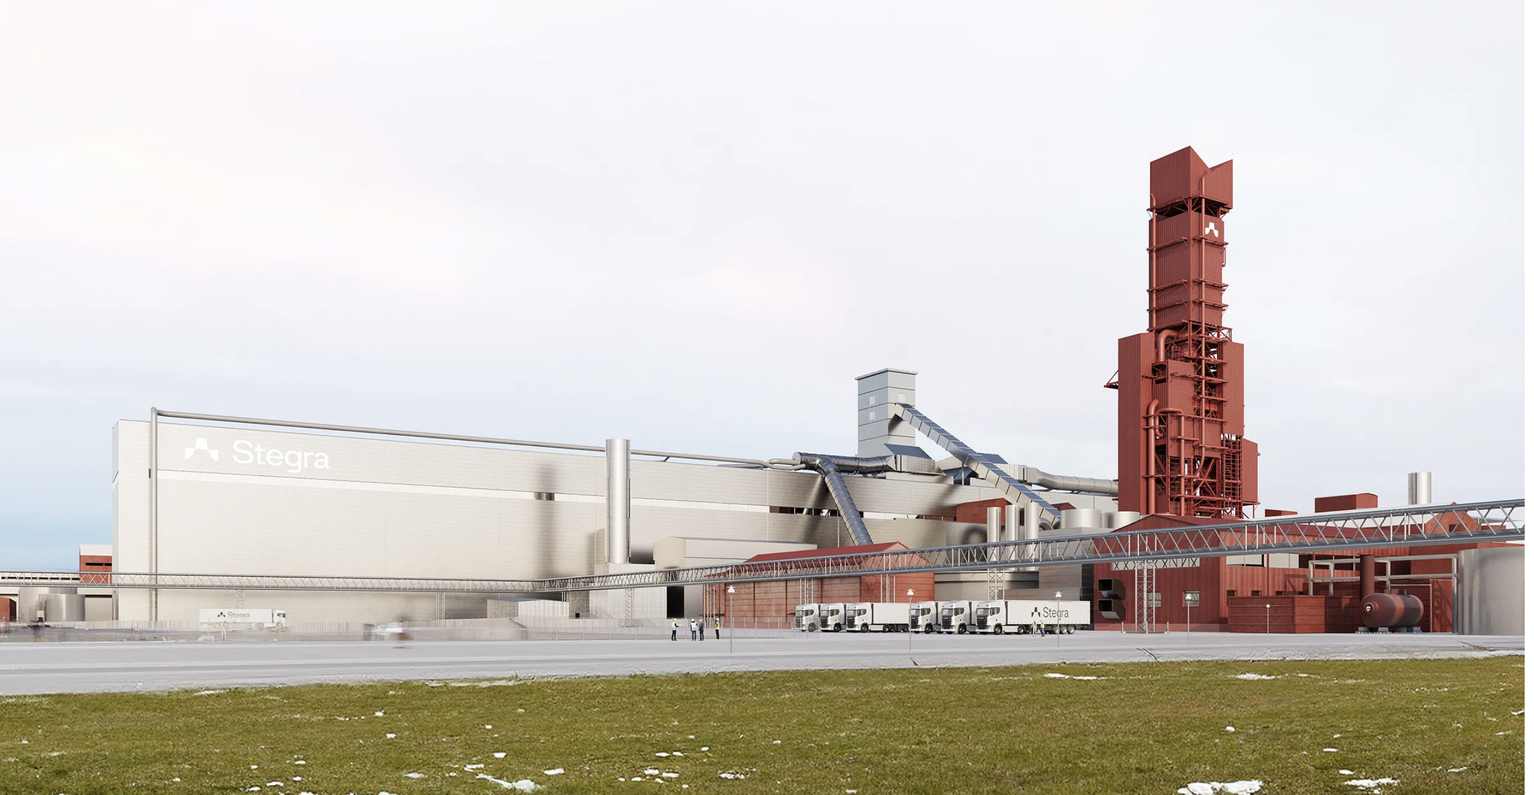
Stegra facility. Source:Company
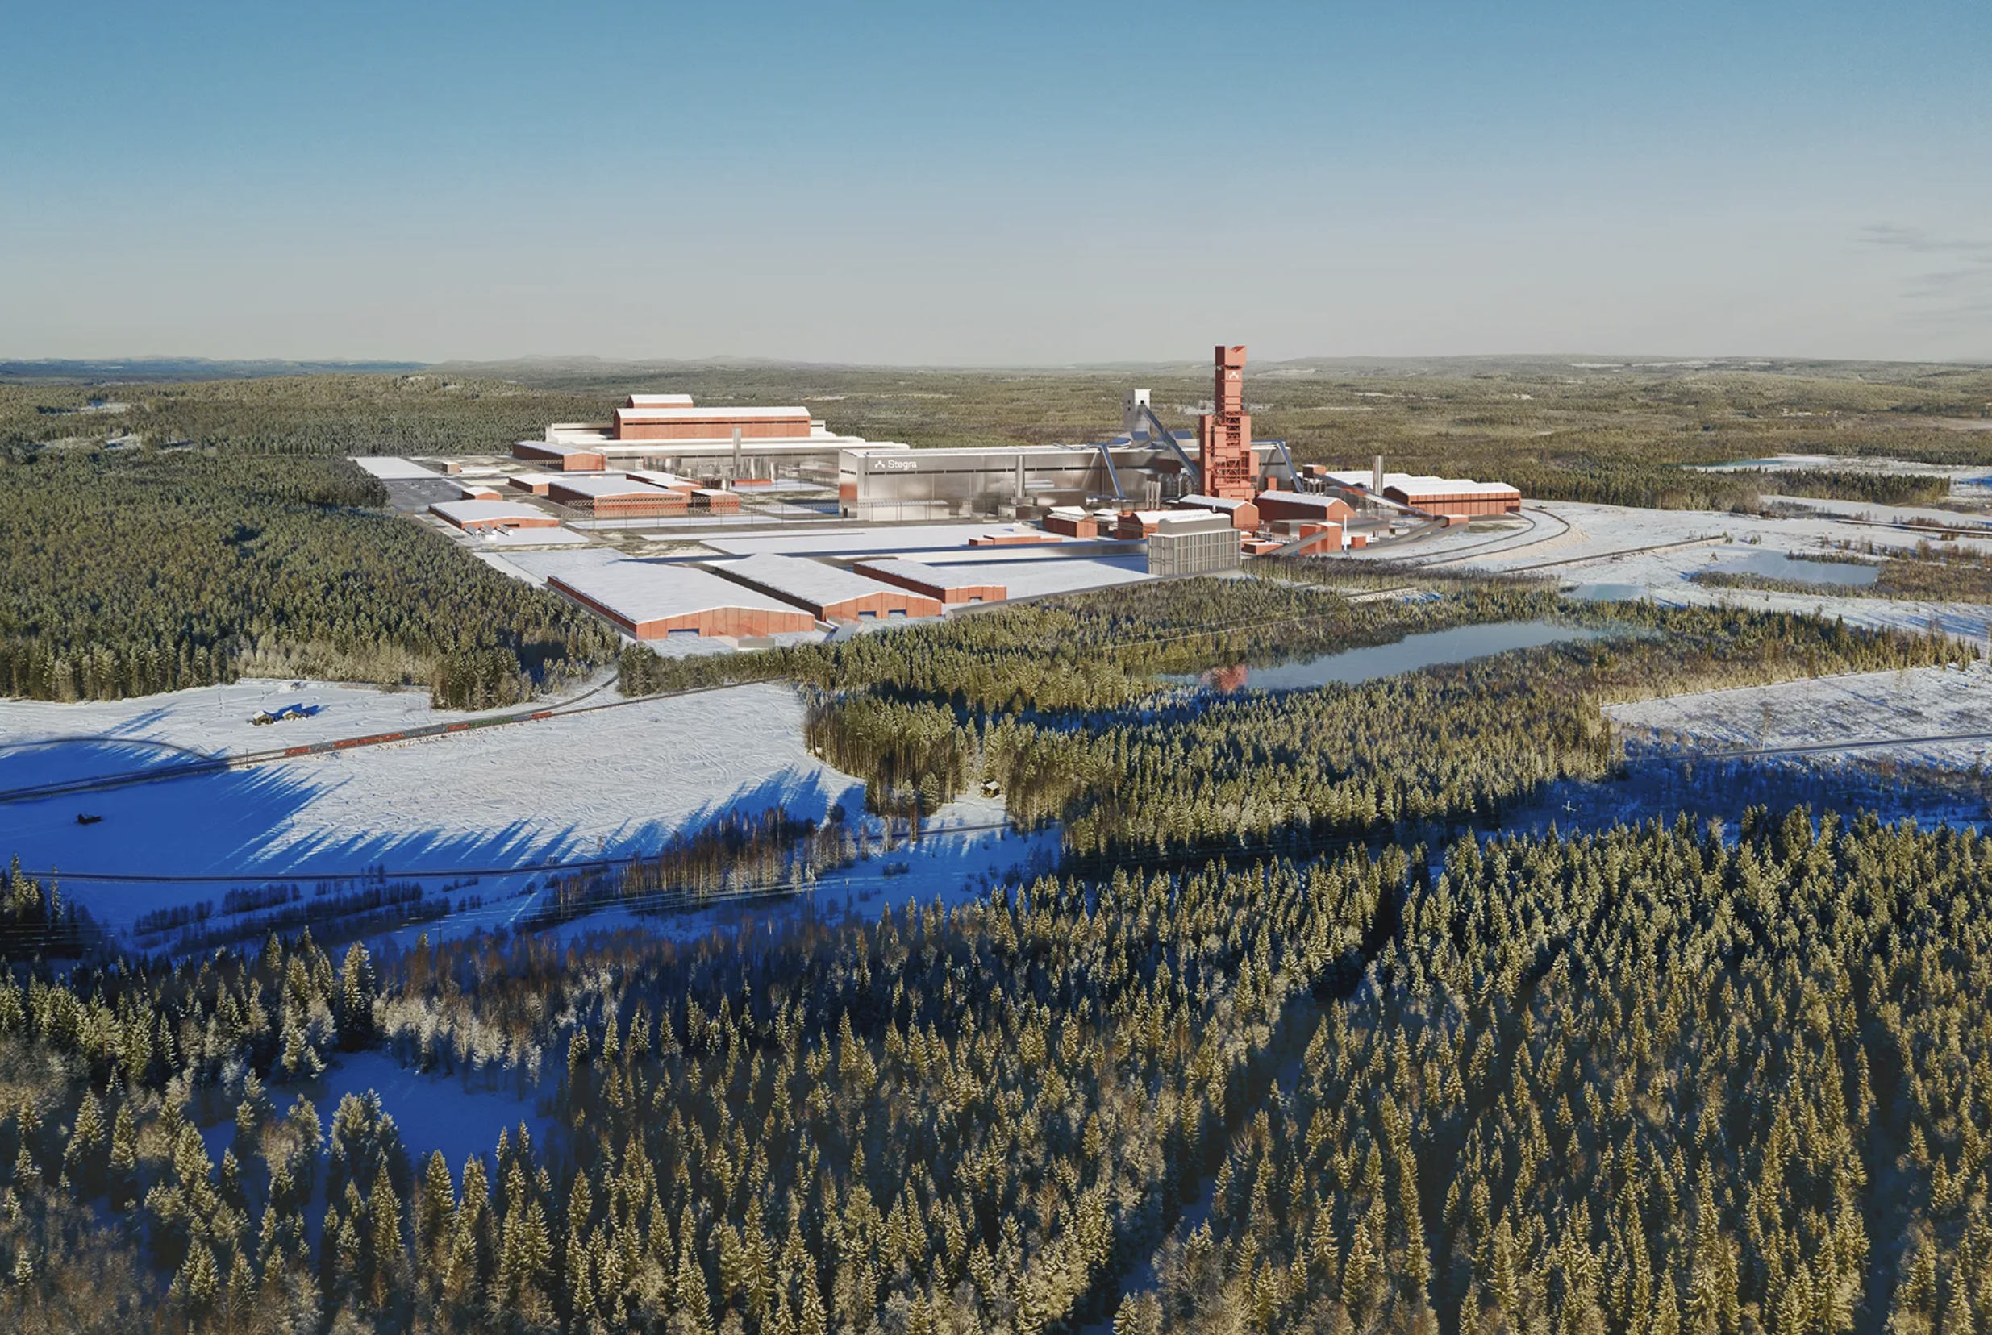
Stegra facility 2. Source:Company

Project Foundation and Strategic Position
The Stegra Green Steel project represents a pioneering initiative transforming steel industry production through near-zero emission processes utilizing green hydrogen technology. Located in Boden, northern Sweden, the facility is positioned to become the world’s first large-scale, fully integrated green steel manufacturing plant.
The company was established in 2021 under the H2 Green Steel designation with a focused mission to decarbonize global steel production. In September 2024, the organization rebranded to Stegra, reflecting expanded ambitions for industrial decarbonization leadership across multiple sectors.

Technical Specifications and Production Capacity
The Boden facility integrates advanced hydrogen-based steel production technology through a 700-800 MW electrolyzer system that produces green hydrogen for direct reduction processes. The hydrogen replaces traditional coal-based reduction methods, enabling sponge iron production that subsequently undergoes processing in electric arc furnaces powered by renewable electricity sources.
Production scheduling targets initial output of 2.5 million tonnes of green steel annually beginning in 2026, scaling to full capacity of 5 million tonnes per year by 2030. The manufacturing process achieves CO₂ emission reductions of up to 95% compared to conventional steelmaking methods, establishing new industry benchmarks for sustainable production.

Financial Structure and Investment Profile
The project represents approximately €6.5 billion in total investment, supported by substantial government and institutional funding mechanisms. Financial backing includes €265 million from the Swedish government through various support programs and €250 million from the EU Innovation Fund, demonstrating strong policy alignment with European decarbonization objectives.

Customer Portfolio and Market Commitments
Stegra has established comprehensive long-term offtake agreements with leading companies across diverse industrial sectors, providing substantial revenue visibility and market validation for green steel demand.
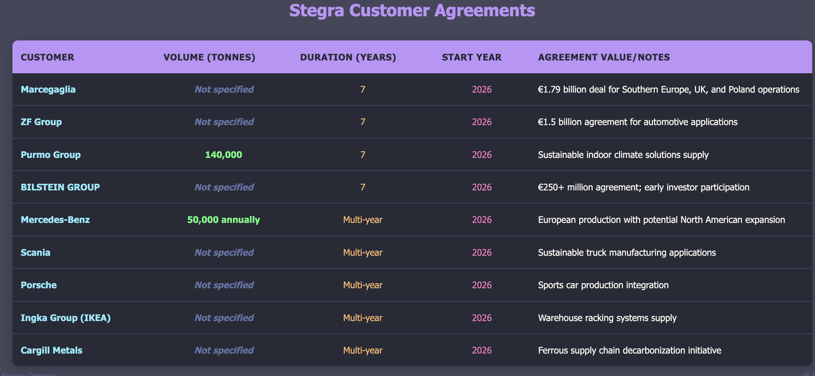
Stegra customer arranagements. Source:Company
Additional supply agreements and term sheets have been executed with BMW Group, Electrolux, Kingspan, Klöckner & Co, Lindab, Roba Metals, Schaeffler, and Zekelman Industries, demonstrating broad market acceptance across automotive, construction, and industrial sectors.

Strategic Market Impact
The Stegra Boden plant represents a transformational development in sustainable steel production, aligning with global industrial decarbonization initiatives and European climate policy objectives. The substantial customer demand and binding offtake agreements demonstrate market readiness for premium green steel products, validating the commercial viability of hydrogen-based steel production at industrial scale.
The project establishes Sweden as a global leader in clean steel technology while creating approximately 2,000 direct operational jobs and 4,000 construction positions, contributing significantly to regional economic development and industrial competitiveness in the transition to sustainable manufacturing processes.

