Pellets

David Leitch

2025-06-10

# Iron Ore Pelletization Process and Strategic Value

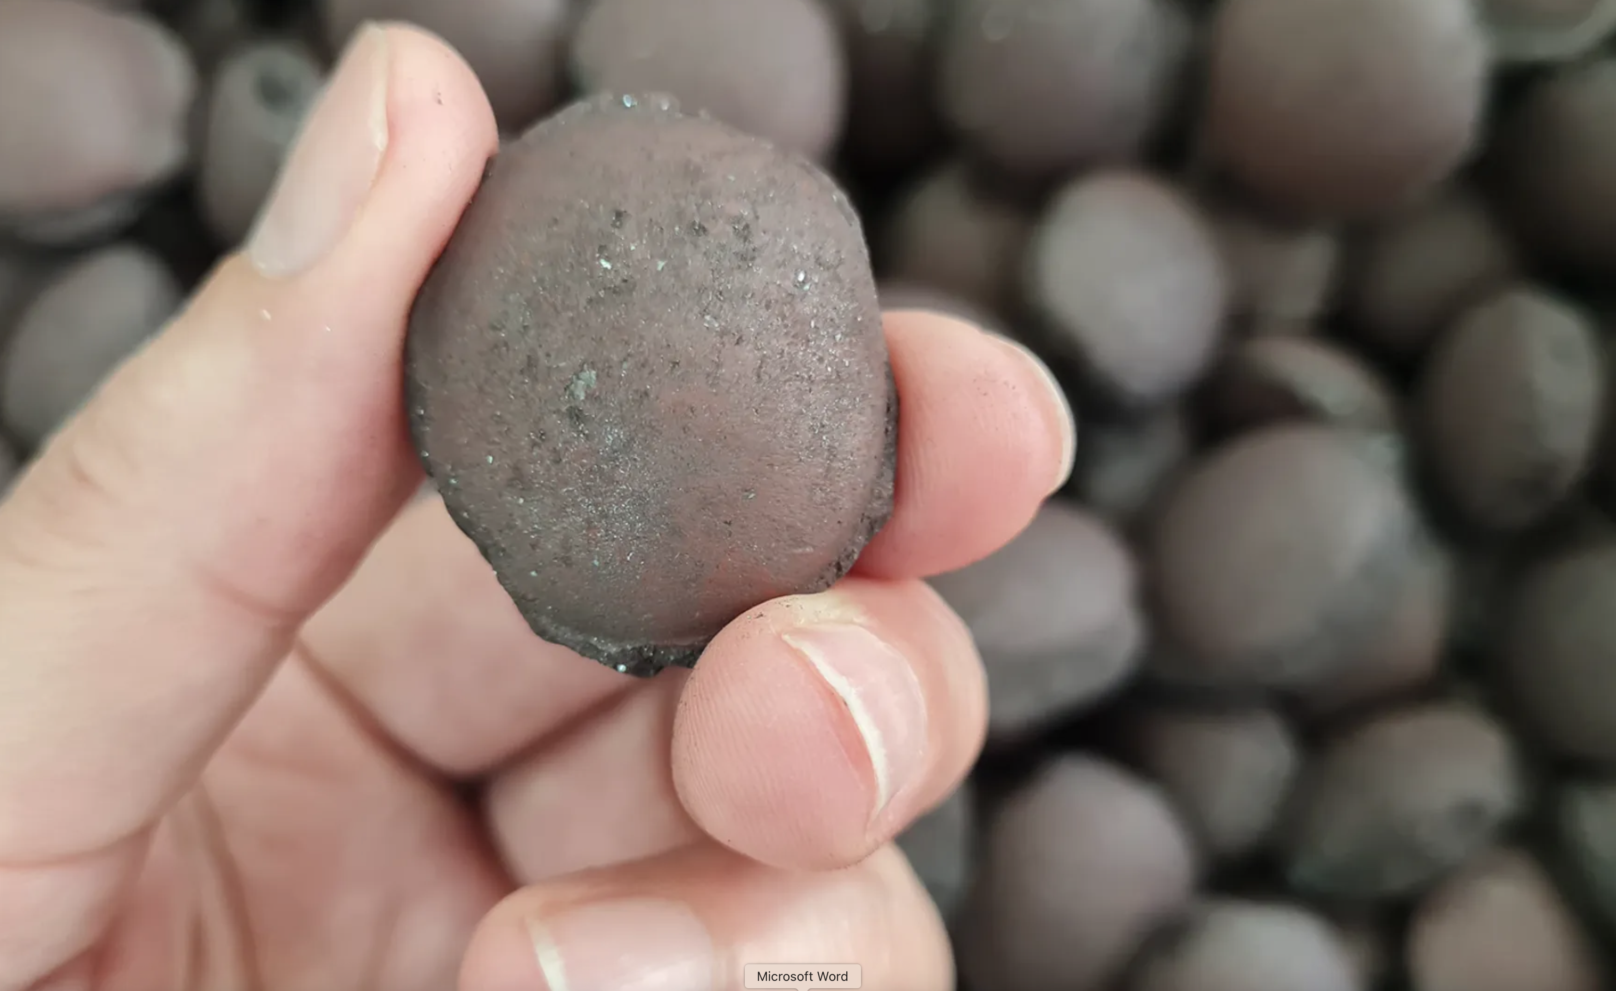

Pellets, Source:Stegra

## Purpose and Benefits

Raw iron ore is typically mined as fines or lumps, with fines being too small for direct use in blast furnaces or DRI reactors. Pelletization addresses several critical operational challenges while enhancing ore quality and value.

Pellets provide improved handling and transport characteristics through their uniform spherical shape, which reduces dust, spillage, and degradation during logistics operations. The pelletization process upgrades iron content to 64-67% Fe compared to 55-62% in natural ore, representing a significant quality enhancement. The resulting pellets exhibit superior reactivity in furnaces due to higher porosity, which improves gas flow and reduction rates in DRI plants. This enhanced reactivity makes pellets particularly essential for hydrogen-based DRI processes, which are more sensitive to ore quality requirements.

## Manufacturing Process

The pelletization process follows a structured four-stage approach. Initial crushing and grinding reduces iron ore fines to very fine particles, typically under 0.1 mm. Optional beneficiation removes gangue materials such as silica and alumina through magnetic separation or flotation techniques.

The balling stage involves mixing fine ore with binders like bentonite and rolling the mixture into green pellets measuring 8-16 mm in diameter. The final induration step heat-hardens pellets in rotary kilns or grate-kiln systems at temperatures of 1300-1350°C, sintering the pellet into a physically strong and chemically stable product.

## Energy Requirements and Environmental Impact

Pelletization is energy-intensive, particularly during the induration phase. Thermal energy consumption ranges from 1.5-2.0 GJ per tonne of pellets, primarily sourced from natural gas or coal. Electrical energy requirements total 50-70 kWh per tonne for grinding, balling, and conveyor operations. Total CO₂ emissions range from 90-130 kg per tonne when fossil fuel-based energy sources are utilized.

Green alternatives are emerging as some pelletizing plants explore electric or hydrogen-based heating systems to reduce emissions profiles.

## Strategic Role in Green Steel Production

Pellets serve as a key enabler for DRI-based green iron production. Without pellets, DRI reactors, especially hydrogen-based systems, face operational challenges including clogging and efficiency losses. Pellet export capabilities allow resource-rich countries like Australia to sell higher-value, pre-processed ore products that support global decarbonization efforts without requiring domestic final metal production.

## Process Summary

The pelletization process transforms low-grade ore fines into premium feedstock suitable for modern steelmaking technologies. Key specifications include energy consumption of 1.5-2.0 GJ per tonne primarily for thermal processes, with particular optimization for hydrogen DRI and electric smelting furnaces. Export potential captures enhanced value while supporting international green steelmaking initiatives.