CHATTER

David Leitch

2024-12-09

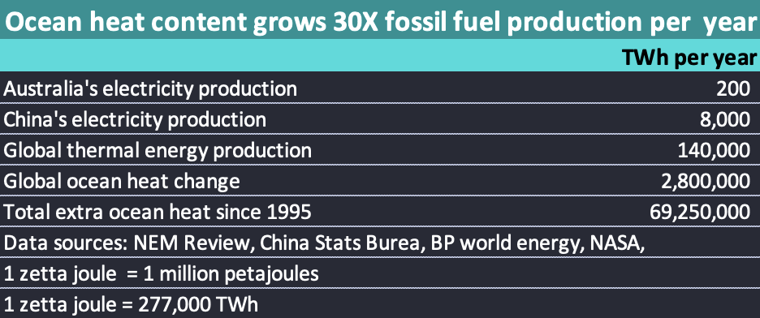

Ocean heat content compared to energy production

### 19 Dec

Can’t drive just yet so spending some time trying to make this chatter file update without reloading entire site. Making the technology doing something Quarto wasn’t really designed to do.

Also spending pleasurable time watching Danny Price on the defensive, trying to justify the house of cards he so carefully built to justify nuclear. In the process amongst many other issues seeing him dismiss the AER cost of carbon as just wrong, like how would he know, state as a fact that AEMOS’s ISP coal closure timetable was wrong and in general try to show that what he did was fair and reasonable when in fact it was very far from that.

And seems like I have the netlify serveless function working :-)

### 18 Dec

**A vote for the LNP is a vote for blackouts.**

Australia has relatively few coal stations now although they still account for about 61% of total NEM wide energy. Every unit that has a forced outage, or even a planned outage represents a material share of supply just now.

If the LNP has their way they will expect to keep this already unreliable system as the backbone of supply for the next 15 to 20 years while nuclear plants are built. The risks for the sake of ideology are basically insance from Australia’s best interest. National security, growth in the economy, the well being of the “State” are all threatened by this ideological crusdae. A crusade that is entirely unsupported by the industry on which it will be forced.

Australia cannot afford the risk.

And I hear Danny Price is being his usual difficult self.

Finally for today it was a pleasure to interview Chris Bowen for the last episode of EnergyInsiders, and a good interview it is, in my opinion. The audience was down a touch this year to 700k so we have a way to go catch “the rest is history” and yet I felt well on top of the subject. Priorities next year will be a little more international interviews, and a little more climate change.

### 17 Dec

Changes to the front page look, hopefully for the better. Actually took all day fiddling with various Quarto options and demonstrating my lack of skill at this task but now part 1 done.

### 16 Dec

Back from hospital. I had excellent surgeon and I believe anaesthetist but I still dont recommend a major mitral valve repair, 7 hours on the table emerging like a pin cushion with garden hoses popping out the tummy etc until its necessary. Mine was and glad to get it done.

As a result haven’t caught up on the electricity data fully for a couple of weeks and there are a couple of temporary data issues. I update my data for key charts and tables only once a week and the latests is available from the “NEM-dash” menu item. Nevertheless spot prices are clearly way higher this year than last running over $200/Mwh in NSW.

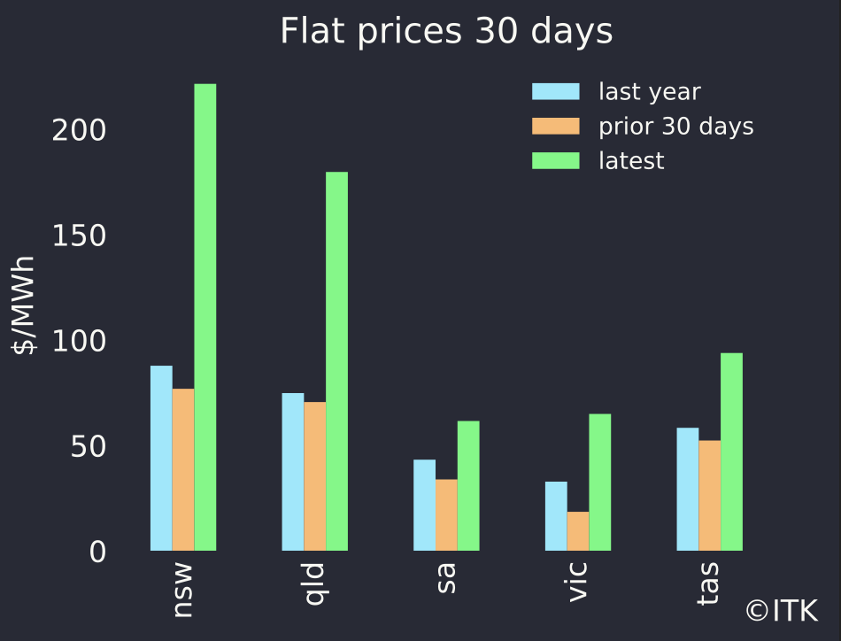

flat load prices, data source: NEM Review

The reason for high prices is obvious. Coal generation is down and besides rooftop its gas and hydro that have had to make up most of the difference.

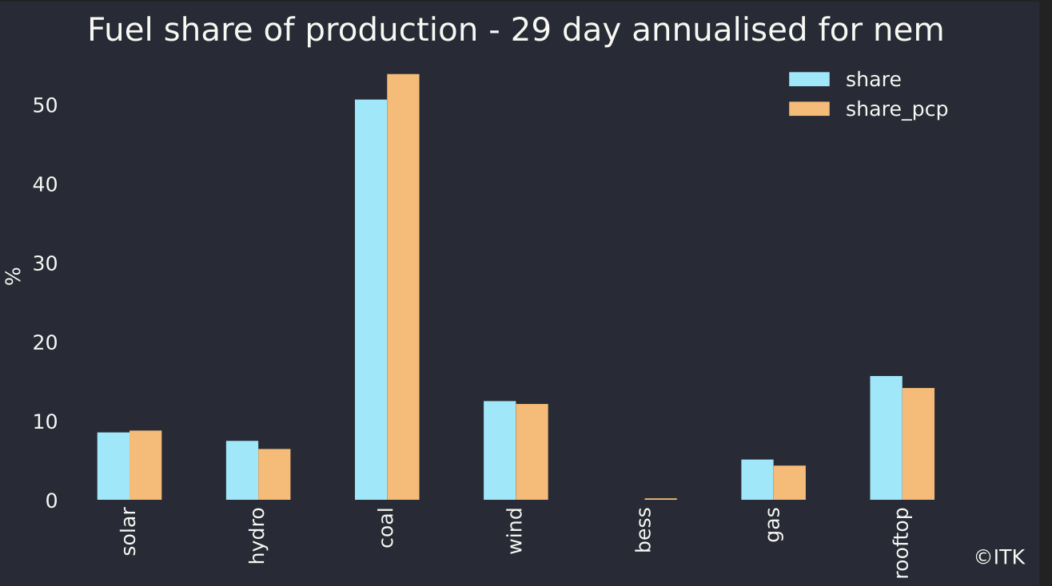

fuel share of production. Data source NEM review

Overall wind conditions have not been all that special and its quite normal to have a wind down turn at this time.

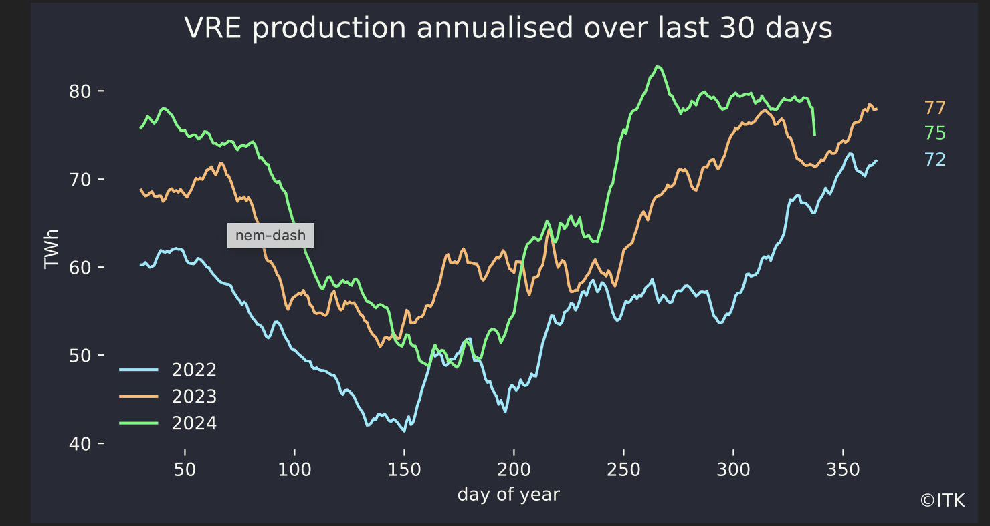

VRE Data source: NEM Review

Of the three big wind farms Macintyre (1000 MW) hit max output of 70 MW, Golden Plains hasn’t done much over 50 and Clarke Creek is still in very early days (4 MW)

### 5 December

At Carl Daley at [Wattclarity](https://wattclarity.com.au/articles/2024/12/wrap-up-of-price-spikes-in-november-2024/) points out that the last week of November is often when price spikes occur. The only explanation I can think of is that November is when coal generators do maintenance and weather is a bitt hotter than in the main part of Spring so demand can be relatively elevated. Demand in NSW never got with in 10% of its all time record but there were certainly price spikes. The following figure, done in a hurry as I am off to Hospital in an hour for a long standing valve leak repair, shows NSW 5 minute prices for most of this year(or as long as I’ve been downloading the data.)

Until there are more batteries online I expect to see these 5 minute price spikes continue. They certainly push up average prices.

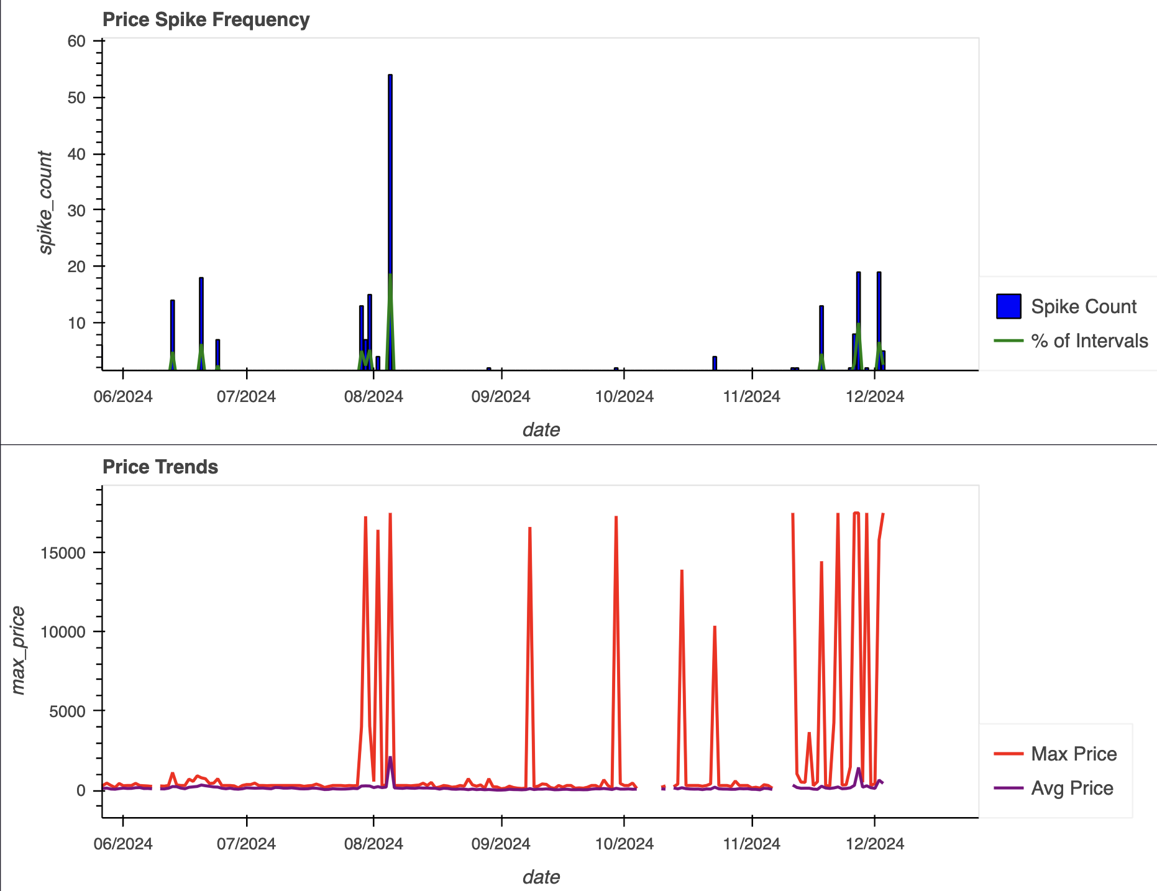

NSW 5 minute prices, Source: Nemweb

### 29 Nov

The new [CEC Board](https://cleanenergycouncil.org.au/about-us) is a bunch of industry heavyweights including CEOs of Squadron, Iberdrola Australia and Acciona Renewables head Australia.

Despite its work on standards and despite its leading conference I have long felt that the CEC has been losing ground to Smart Energy as the main tempo of the industry. Smart Energy takes stronger positions and is generally more aggressive in its marketing. Attendance at its exhibition/conference is free which is in contrast to the CEFC summit. All Energy equally remains free to visitors.

There are therefore at least three organisations committed in part to lobbying and developing policy, the CEC, Smart Energy and the Clean Energy Investor Group(CEIG). There now seems to be considerable overlap between the CEC and CEIG.

Given that CEC Board positions were heavily contested this year I expect to see some change in the CEC focus and activity over time.

To me it looks like the CEC is increasingly going to be the big end of the industry and Smart Energy is going to be the organisation for everyone else. That’s already been the case I guess for a while but looks to be even more so.

## 29 Sep

Please to report my latest monthly electricity and petrol bill zero, in fact my retailer stated they owe me $29 which will be applied to the next bill. Despite the cost I expect that attachment rates of batteries to new solar systems is increasing.

Disappointingly even though utility and car battery prices are clearly coming down and in some cases coming down quickly residential batteries have basically been flat for 6 years. At least according to comparison site [Solar Choice](https://www.solarchoice.net.au/solar-batteries/price/):

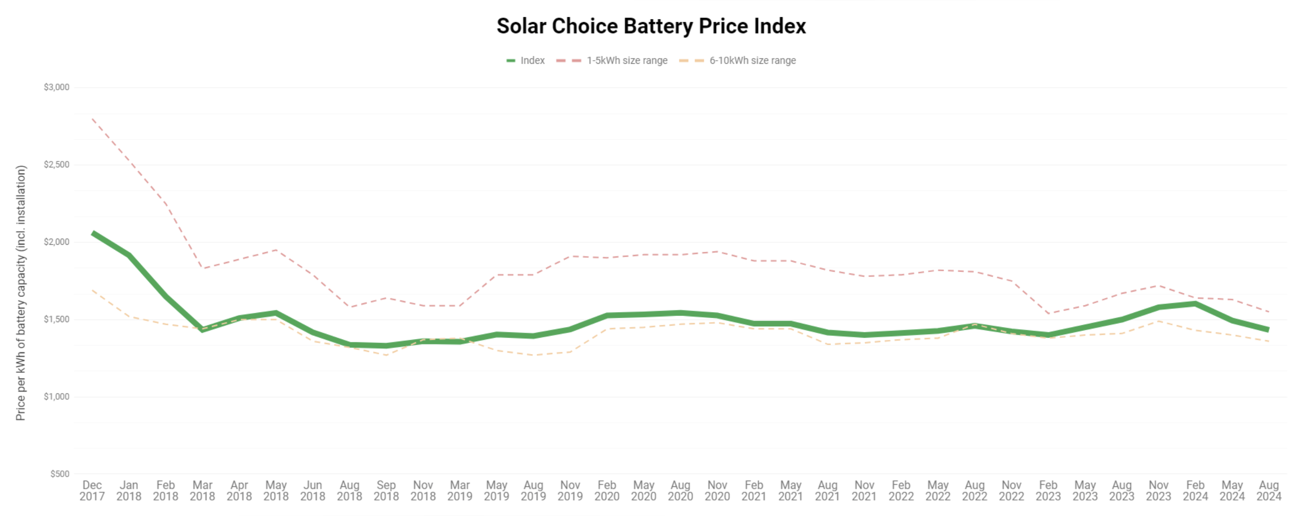

## 1 Sep

Going forward articles will include a comments section. No login is required at this stage as the traffic volume is expected to be low. Comments are generally welcome. I get some email feedback on my articles, the vast majority of which is quite value adding. It seems to me that in many cases that feedback would often do more good being in a comment for others to read.

### 23 Aug

ITK’s price forecasts are coming soonish.

### 7 Aug

Updating some previous numbers the going rate for a 6 MW wind turbine seems about $60k per year. So the 54 turbines of Doughboy windfarm that 9 landowners turned down is about $3.2 m or $97 m over 30 years. Lots of money to give up for any reason. Things must be good in the bush although my understanding 6/9 potential hosts weren’t even residents.

### 19 July

Whitehaven reported coal production costs of A$114/t. Price received for NSW thermal coal of US$137/t (A$210/t). That’s likely for top quality thermal coal (26 gj/t) but even so translating that back to NSW coal generation for say Eraring gives 9.5 GJ/MWh * 210 / 26 = $76/MWh fuel cost.

### 8 Jun 24 78

Am emerging leading light in understanding social cohesion and division in the transition is Associate Professor Rebecca Colvin.

“So, for instance, quite a bit of research has shown that Australia is the second most polarised country on climate change along left-right political lines, with the US being the most polarised country.”

[100climateconversations](https://www.100climateconversations.com/bec-colvin)

A topical quote considering todays headlines that the LNP is more or less turning its back on Paris commitments.

### 5 Jun 24

A reminder tha there are 20 GW of wind and solar operating

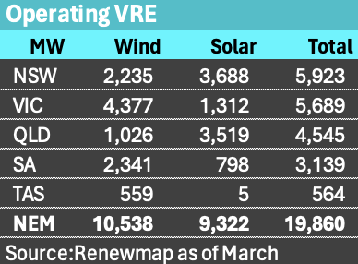

And the total is set to grow 30% based on projects under construction, although Rye Park 400 MW wind could now be regarded as operating reducing the growth rate.

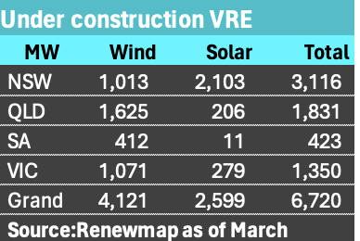

## 3 Jun 24

## CIS scheme webinar

* Not a lot of real news but well attended plenty of Q&A. In response to my question about will it get new capacity built there seems to be a general focus rather than specific provisions. Ie choosing projects that are capable and will be built. Comes down to who is doing the administering.
* Focus on getting the right number of bidders as the assement process will take months, and too many will slow it down.

## 2 Jun 24

#### Renewmap is the go

[renewmap](www.renewamap.com.au) is the best new site to open in 2024. Great map based coverage of esxising, being constructed and proposed generation

#### Binsted Chair NSW Energyco

As announced [here](https://www.energyco.nsw.gov.au/about-energyco) Paul Binsted, Chair of Stanwell has been appointed Chairpoers onf the Board of the Energy Corporation of NSW. CEO is Paul Hay.