As countries grow wealthier there is a mild decline in energy intensity
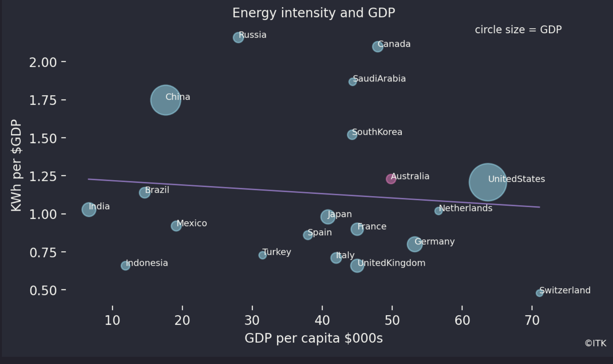
GPP v energy, Source:“world in data”,wikipedia

