8 hour average prices
David Leitch
2024-04-14

8 hour price averages
One of the things I am constantly on about these days is the value of power over duration. Given a choice between more power and more duration I choose the former.
Nevertheless I had a quick look at 8 hour average prices ove the past 12 months. 8 hours is the sort of number talked about in pumped hydro sector. But how much more useful are hours 3-8 over hours 1 and 2? There are a few different answers to the question. ITK’s Nem-dash shows daily spreads for different durations but here I just look at average prices:
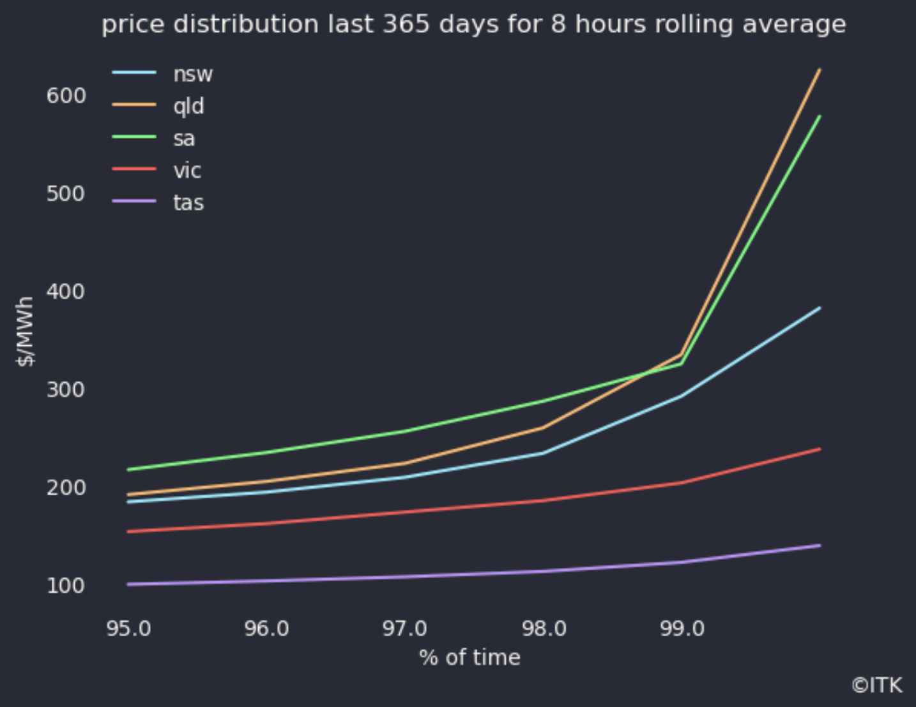
top 5%, Data source: NEM review
and for the low side if you are charging your pumped hydro
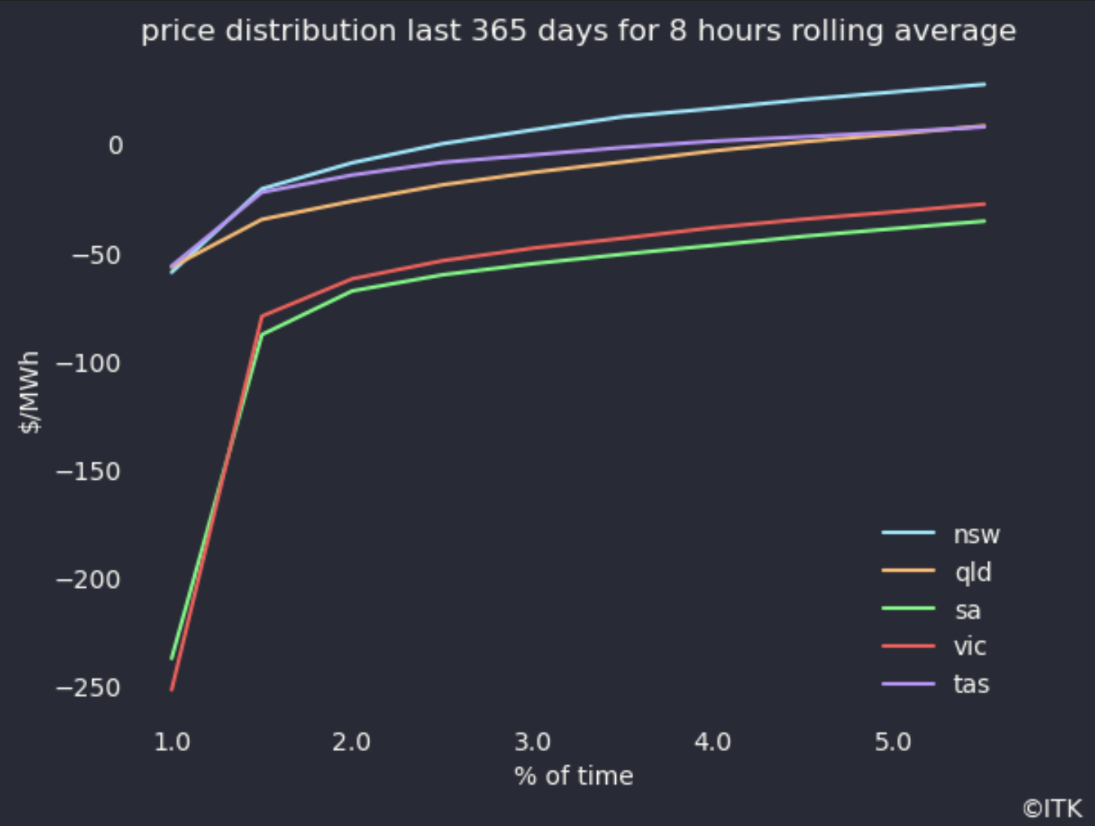
lowest 8 hour average prices. Data source: NEM Review
Of course price is way more complex and nuanced than these simple graphs, but they serve as a reminder of highs and lows.

