Move over once, move over twice
David Leitch
2024-02-26

Crossing over in 2025 the way to 2030
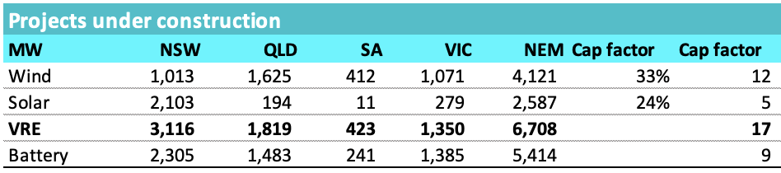
Under construction,Source:wwww.renewmap.com
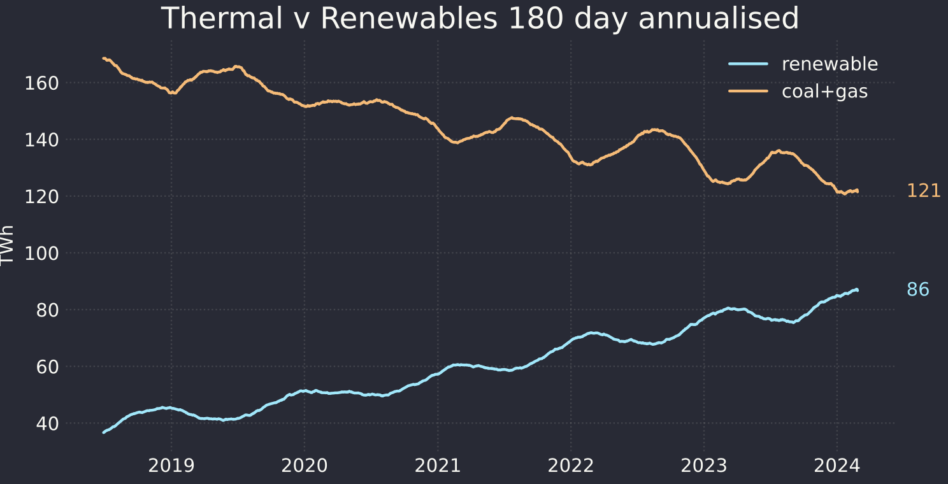
Progress,source: NEM review
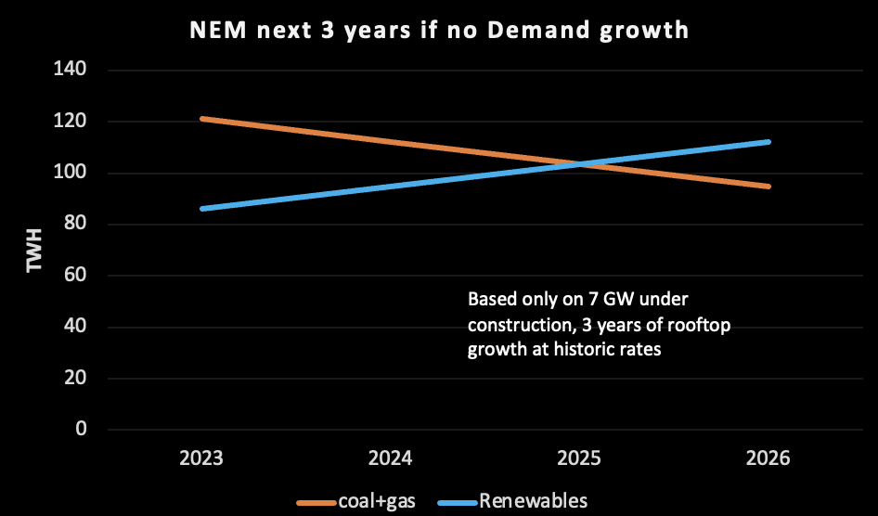
Over 50% in late 2025, source: ITK estimates

