More transmission please

David Leitch

2024-05-27

# Not enough transmission was built before solar got going in Victoria and NSW

The following figure shows a rolling 90 day average of actual and the AEMO prescribed limit of transmission northward from Victoria to NSW between the hours of 10:00 am and 3:00 pm. These times were chosen because that’s when solar operates.

As the figure shows over time there has been a reduction in the limit. Further the limit is very seasonal much lower in Spring and Summer than Autumn and Winter. For one 90 day period the average limit gets down to below zero in the solar hours. That is there is no capacity to transmit between Victoria and NSW. That’s not a limit because so much power is going across the interconneector. Its a limit tha says no power CAN go across the interconnector at that time.

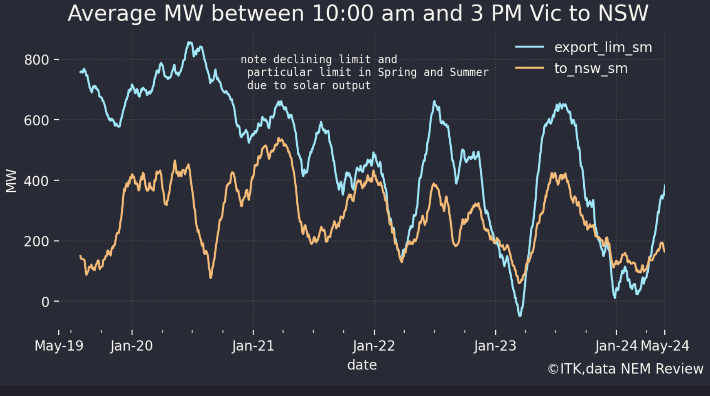

Vic to NSW actual compared to limit, Source: NEM Review

I will leave others to decide what to do about it, but its quite possible it will get worse before it gets better. That’s because when Stage 1 of the PEC is completed more power can flow South and East but no more can flow North.

Elsewhere the recent wind drought is showing up in the year on year comparisons.

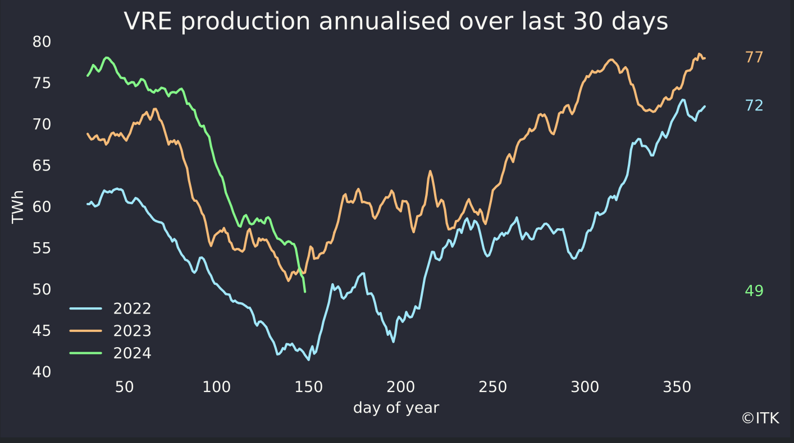

VRE production, Source: NEM Review

Solar is seasonally soft but this year there has been a wind drought. Of course the anti renewables crowd will point to this but I am fairly confident that when some of the 3 GW of wind projects in QLD come on line over the next 18 months, the fact that QLD”s wind does well in Winter will be a help.

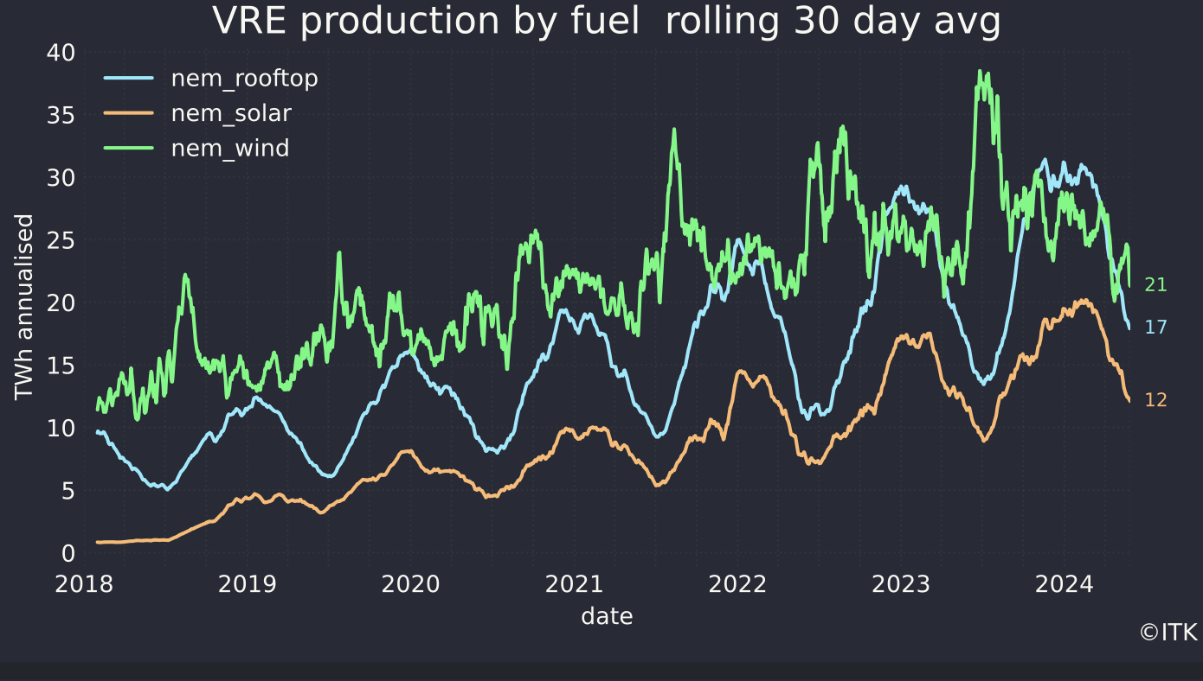

VRE by fuel. Source: NEM Review

As a result spot prices in Victoria and South Australia are well above recent levels showing seasonal growth even though steady or lower than last year and futures have taken fright

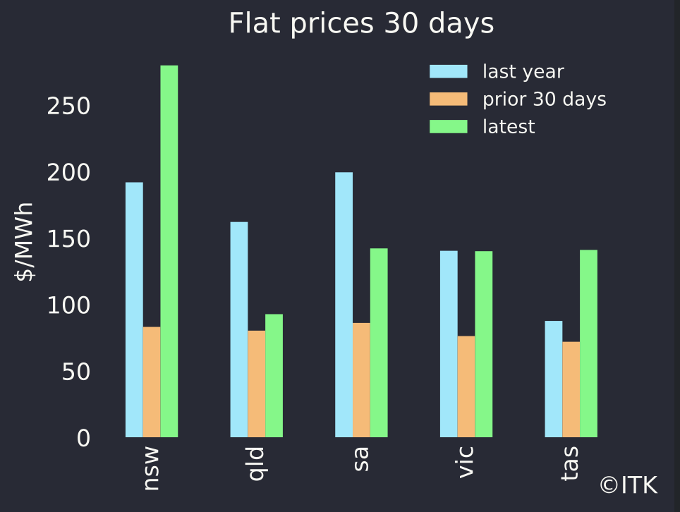

Spot prices. Source: NEM review

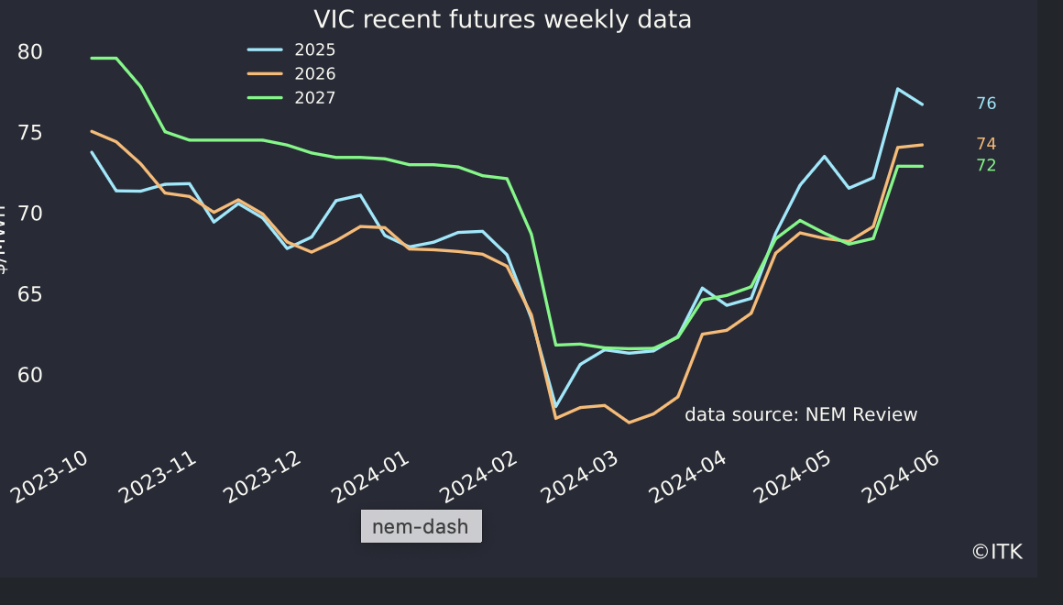

Vic futures. Source: NEM Review