NSW is a lucky State
I was going to write about NSW wind farm progress. But there is nothing to write about.
There is probably a lot of talk going on at the clean energy summit. Talk is about all the industry does these days and the Summit is no doubt a good place to do it.
For the record Uungula was the last wind farm to reach FID in NSW in Dec ‘23’ more than 30 months ago.
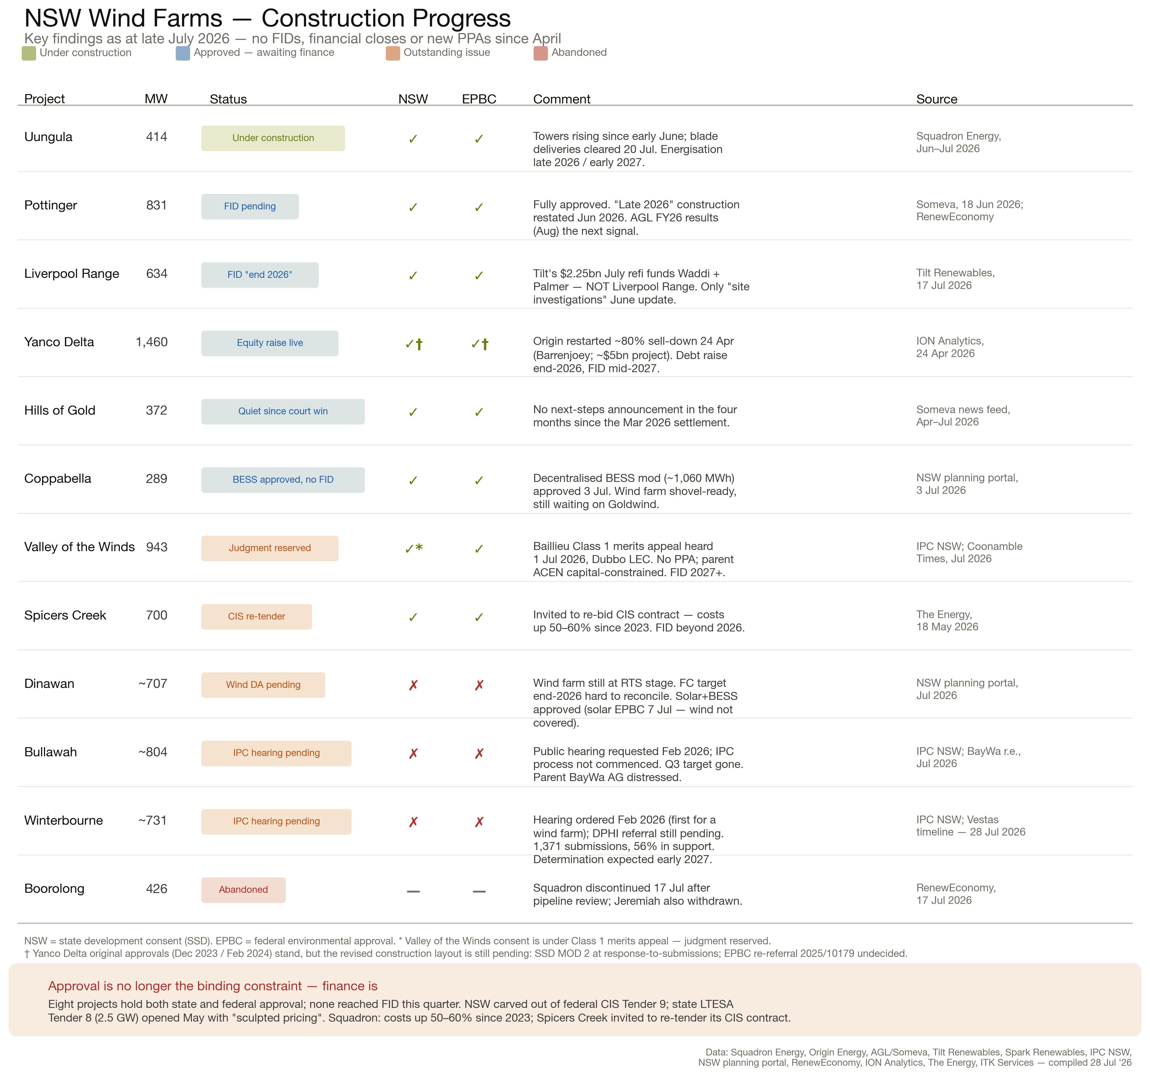
nsw_wind_findings

