Is the productivity commission for real?
As far as I can tell one of the least productive organisations in Australia is the productivity commission. It seems to write reports that are largely ignored, and even if adopted would hardly move the dial.
It’s not the organisation that Australia needs to move forward, at least not in my opinion.
Normally the commission is an organisation that you would avoid like the plague. I read one of their reports on health and I was astonished at the limited concepts and definitions of productivity let alone the paucity of the actual recommendations. This was based on my feeling as a patient and seeing nurses recording patient measurements and then typing them into machines. A process that takes up considerable shift time and where it seemed to me that automated instrument to machine reporting was a way forward I could see Amazon doing it the way the hospital does.
Anyhow back on topic:
The Commission’s latest opus is on “Impacts of heavy vehicle reform” (undated on the front cover)
“Key Points
- Heavy vehicle transport is important but productivity has stalled.
- The largest potential productivity benefits will arise from reforms that increase access to Australia’s road network for high productivity vehicles. This key productivity reform amounts to allowing heavier trucks and might increase GDP by around 0.03%-0.10% or about A$1 bn. Cheez.
- Adjusting noise based curfews and building more charging infrastructure will help the uptake of electric trucks. Double cheez with sauce. Is anyone still awake.”
The whole thing is frighteningly boring but I persevered and came across recommendation 4.1
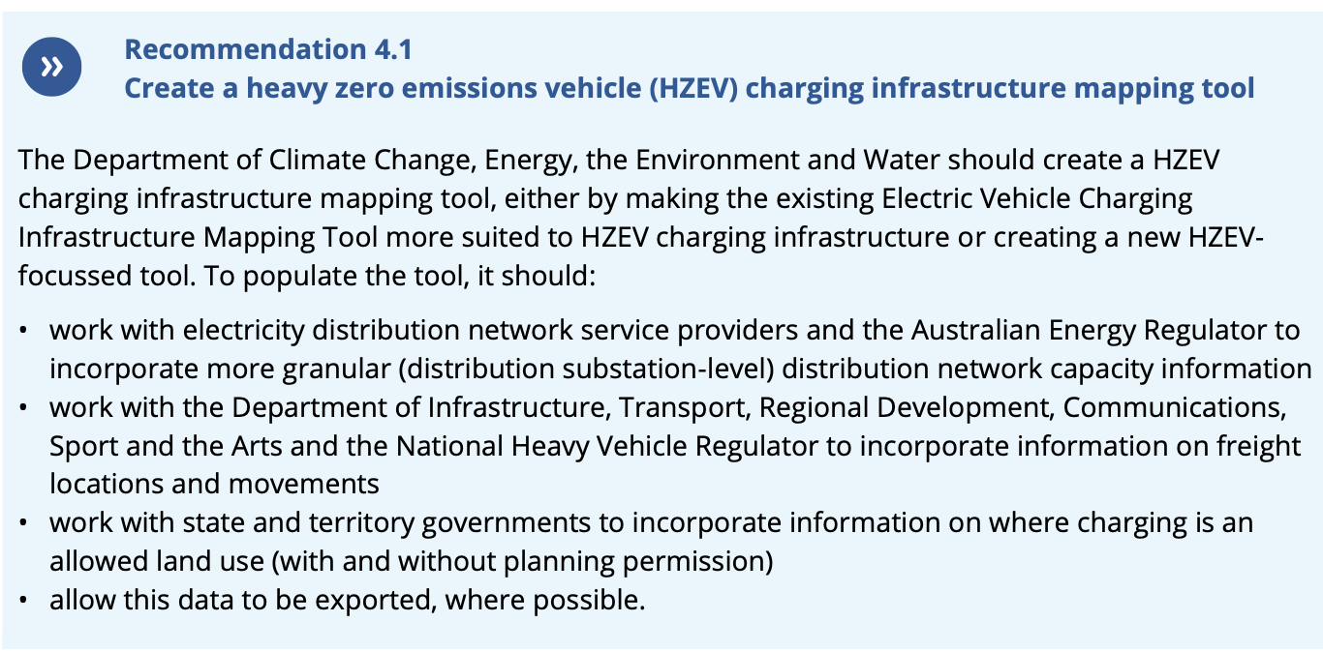
image-20260818135436474
So what is this “Electric Vehicle charging infrastructure mapping tool” I wondered? Maybe the Govt is more uptodate that it appeared.
Unfortunately not. The map is a nearly perfect example of a project that started out well and then has just been left to wither on the vine. Good intentions resulting in what looks like a complete waste of money. Specifically charging stations were last updated July 2025. You can specify KW range etc, etc.

What use is this kind of map?
In my view truck charging

Using EV trucking to increase productivity
In my view electric trucks increase productivity in the following ways, listed as they come to mind:
- reduce the costs of transport by lowering fuel costs;
- reduce the health damage from diesel ($6 bn per year).
- reduce national security costs via lower or eliminated diesel fuel reserves;
- reduce environmental damage eg floods and droughts through less global warming;
- increase national well being, eg happier drivers, less noise etc.
As is usual productivity most comes by substituting capital for operating costs. In this case the perhaps higher costs of the trucks but the biggest component is the charging infrastructure and the electricity investment.

