People policy
David Leitch
2024-03-14

People before IRA - where’s our slogan?
A wealth of research suggests that the utility scale renewable energy industry would be better served by putting more emphasis on the people side of things rather than the financial policy. I think it was the RE Alliance that first made this clear to me personally. Before that I just took it as self evident that the need to decarbonise and the benefits to regional Australia massively outweighed what I continue to see as minor costs. But what I see is not what regional Australians see.
Consider the “what happens when the wind don’t blow and sun dont shine” question. In my view the broader community doesn’t trust a system relying on renewable energy. The fact that it will work hasn’t been internalised by the broader community. Even people that own large energy intensive industrial facilities need a lot of convincing. So far the best analogy I have heard is water. It only rains sometimes and unpredictably but we get water when we turn on the tap and on demand. The population doesn’t even think about that, its fully internalised. We need to get to the same place in electricity.
However successful the ISP is as a policy document, AEMO appears to have zero expertise at marketing it. Similarly Goverments show that they “get it” but they do little on the bringing the people with them.
Australians and their Goverments showed the Covid crisis how they could work together to achieve a policy goal. Essentially most of the population ended up being vaccinated. The Goverments’ united front on isolation and vaccination was accepted by a broad majority of Australians.
Something similar may be needed for renewable energy. The ISP messages need to be distilled into a slogan, there needs to be a trusted source of information at the national level.
When we get down to renewable energy zones we know we need to do better. Money isn’t to be ignored but its the social identity and aeons old regional resistance to change that need to be thought about. Change, it seems to me, is generally better accepted when it comes from within. This probably means identifying agents of change in communities and organisations and then getting them to internalise what it means for their community. Not being a psychologist, anthropologist or sociologist I don’t know how to do this but I can see that there is still nowhere enough focus on people, community and population skills compared to the investment in technical and ecoinomic issues.

Industry continues to put financial policyt before people policy
Over the past year or two the renewables energy industry has gone strong on one idea after another. These include:
- Extension to RET;
- Household battery support;
- A USA style IRA with Australian characteristics.
Each of these schemes has its merits and demerits, and I do advocate investment tax support and household battery support. However based on lots of discussion I think all of these schemes miss out on the human element. Economics itself, well particularly the classical theory of finance starts from “rational economic man”. Leaving aside the “man” the assumption was that people made choices based on the hightest utility. An excellent and very informed and also easy to read history of the development of this theory of human behaviour as applied to economics is found at econonomic man to behavioural economics.
Personally knowing how irrational many of my own economic choices were, it came as an ephinany when on a plane flight following a tour of concrete and fibre cement facilities in the USA in the 90s I asked the fund manager I was seated next to what he was reading and thereby started to learn about behavioural economics.
But of course the debate didn’t end there. As the epigram in my favourite finance text states:
“the questions don’t change but the answers sometimes do”
The current state of the art is shown below:
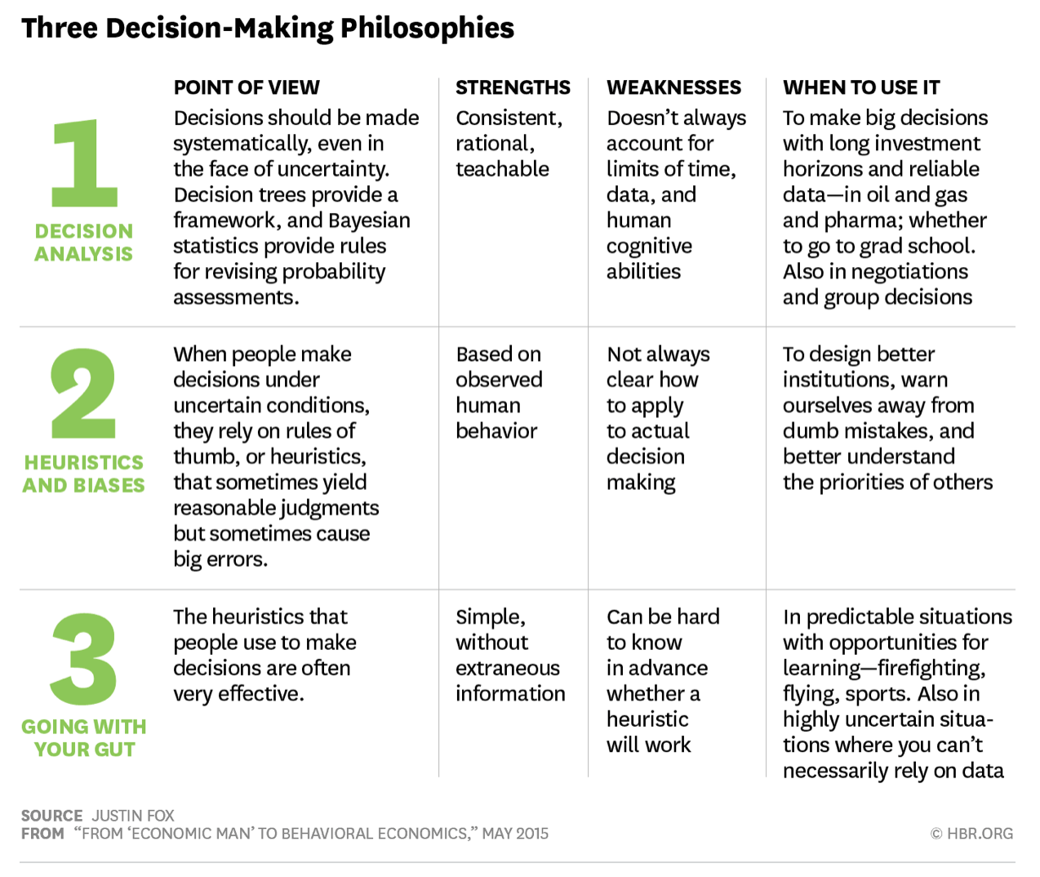
Decision making styles. Source: Justin Fox

The message is not the heuristic but that people matter
So for this discussion its not what process people use in making decisions but simply that people and psychology underly economics and finance. At least to some extent. In the end I personally think that the classical theory of finance and markets where people sacrifice present consumption to enable future consumption in a roughly rational way makes a great starting point.
Other topics that psychologists, anthropologists and sociologists are likely to know about.
- How do people form beliefs.
- What is groupthink
- How do communities or organisations make decisions.
I am not a pyschologist, anthropologist or sociologist but I think that if we want to decarbonise Australia and bring Australians along on that journey then many such people will be required.

When was the last time you heard a psychologist, anthroplogist or sociologist speak at a conference?
We as an industry know how important the job we are doing is. What we want is for local individuals and local communities not only to be welcoming the transition but leading the charge. How nice it would be if landowners invited transmission builders onto their property. How nice it would be, and I think this probably does happen, that land owners would invite wind and solar developers to lease their land. How great would it be if regional councils were leaders of the transition.
How nice it would be if planning depts took the lead in getting things done even if much of the time it seems like their function is to stop things getting done.

Overcome the negatives is better than selling the positives
My personal favourite podcast interview last year was with John Pickering from Evidn. In that podcast he talked about Kurt Lewin’s force field theory. A very non academic description of force field theory is forcefield explained. Pickering noted that Lewin concluded that reducing the negative forces was the way to go. So selling benefits of wind and solar is maybe less effective in regional communities than reducing the perceived disadvantages.
You can read how those concepts were interpreted in the successful “cane changers program” here
Pickering wrote that for the cane farming community signing up was resisted because it threatened their “social identity” and because it required record keeping. In the cane changer example one strategy was “to construct a strong positive social identity”. This was primarily achieved by something as simple as a slogan “Setting the Record Straight” which tapped into farmers’ desire to be seen in a positive light.
Personally I admire the power of slogans. “Its Time”, “Its the economy stupid”,“ute tax”,“think global act local”. In the field of newspapers, in my opinion, its the subeditors who write the article headlines that most influence the tone and power of a publication. In my own case a headline Bad for the budget, good for the state had consquences well beyond what I could have imagined in the 30 seconds it took to write.

A trusted national source of info might be a good start
Kari Dahlgren and Yolande Strengers recently discussed the concept of social license and how can we do better. The report was critical of “social license” seeing it as a neo colonial concept forced on communities by the mining industry and the renewble energy industry is no different. In my view that is a negative if nevertheless informative way to think about the topic. One alternative concept of a license is legal. It is perhaps a contractual right that the licensee has in some way earned for which the licensor is recompensed. Equally a license generally needs to be renewed. This is a concept of bargaining power and equality. A wind farm for instance must negotiate with the land holders. Transmission is different, and this is increasingly recognised. The facility then needs to negotiate with the broader community beyond the directly impacted land holders. That legal view has a different psychology underpinning. A contract will not deal necessarily with social identity, although if it advances a group to a new status, as in some first nation communities, it might do.
Finally it is very clear that not all mining activities are regarded negatively by the communities in which they are based. Whether its social license or some other concept the mine or acttivity ends up getting it strongly. Coal minining communities are often very strongly supportive of coal mines. Communities around coal generation stations of long standing can be very supportive of the facility and resent “do gooders” that want to change them. To my own way of thinking regional areas, like other communities, tend to be resistant to change. “The old way of doing things”, rules thats particularly as the younger folk more open to change tend to move away once they leave school. Those that stay are perhaps by nature more inclined to be change resistant. Regional communities are proud of their way of life, and its often a concious choice. And change tends to be far more obvious in a region than in a large metropolis and the community tends to form a community view. Once something is up and going things settle down. But these are just my personal observations.
Nevertheless its clear the fact that communities need to engage from the start and to participate in process as genunine stakeholders and as hard as it is there is a need to break down the us and them barrier.
One of Dahlgren and Strengers’ observations was to point to Andrew Dyer’s “Community Engagement Report” which Dhalgren and Strengers state acknowledges “the absence of a complling narrative to drive community support for transitioning to cleaner energy sources”. Dhalgren and Strengers pointed out that their research indicated the community wanted a place to find information
In short we need a national slogan and a story to go with it.

