The spot mirage
David Leitch
2026-05-07

Low spot shows the future but hamper the required investment
Prices are too low to support either new generation or old generation. There is no investment signal. As a result, once the current 4 GW is built out, there will be a two year gap before any more supply other than rooftop solar hits the market.
It’s better to have too much electricity supply than too little. New supply has to be built and commissioned before old supply can safely be closed. By definition, when both the new and old supply are operating, there will be excess supply and prices will be lower than those needed for new investment.
Therefore new generation has to be subsidised. Once it’s built, the spot market will provide the incentive for the old generation to exit. The subsidy required for new generation is very roughly LCOE minus expected average spot prices.
It’s not complicated, but a lot of very smart people have made a simple problem difficult by introducing fancy LTESA, CIS and now ESEMs. All investors and consumers ever needed was a flat swap PPA as successfully implemented by Simon Corbell and his team in the ACT.
The finance industry could deliver bids in a week if it had to. Investment banks are exceptionally good at responding quickly. There is no need for months of negotiation. That was already done with the CIS. All that’s needed now is to convert an instrument supporting debt into an instrument leading to investment. Could be done in a fortnight, or at most a month.
That said the NSW Government has bent over backwards to help developers. Hand holding, process streamlining, guarantees on transmission. I really don’t see what more they could do short of offering the PPAs.
More wind and solar capacity reached FID in 2018 than in the last 12 months. Despite the outstanding and wonderful growth of behind-the-meter solar since 2018, I think the need for new operational wind and solar is greater than ever. Not only is demand set to grow but the coal stations are six years older and we are still not at 50% renewables on a 12 month basis.
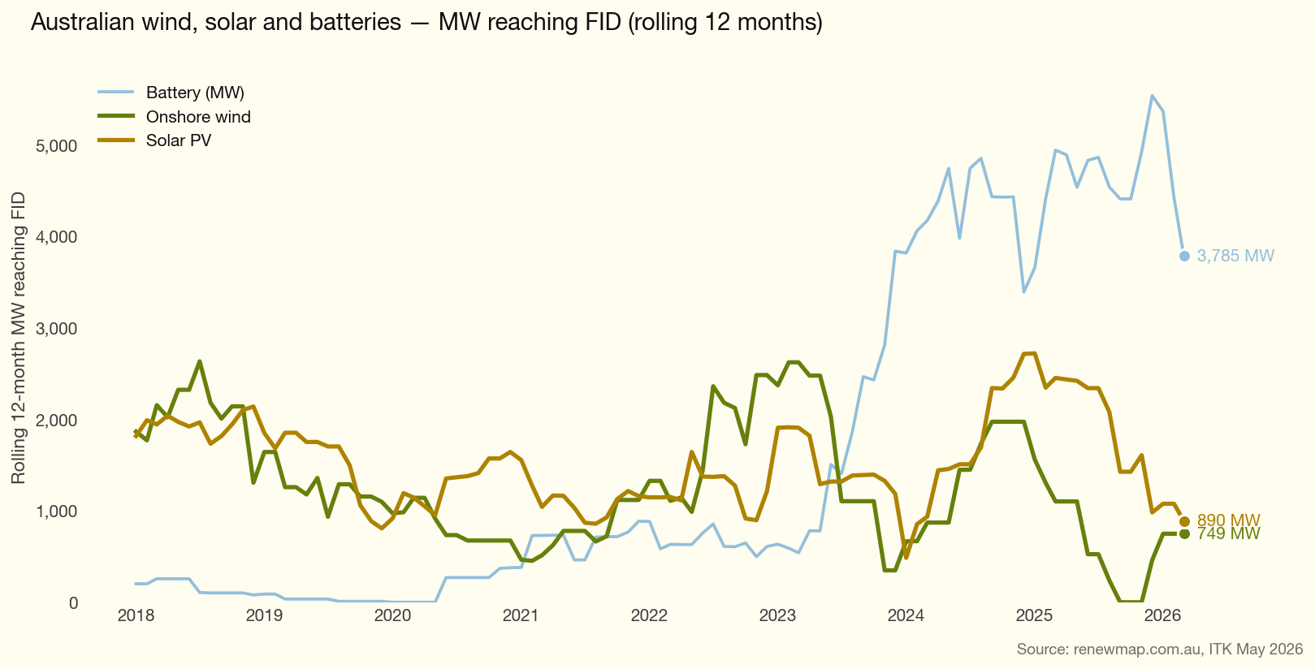
Figure 1: renewmap_fid_rolling12_wind_solar

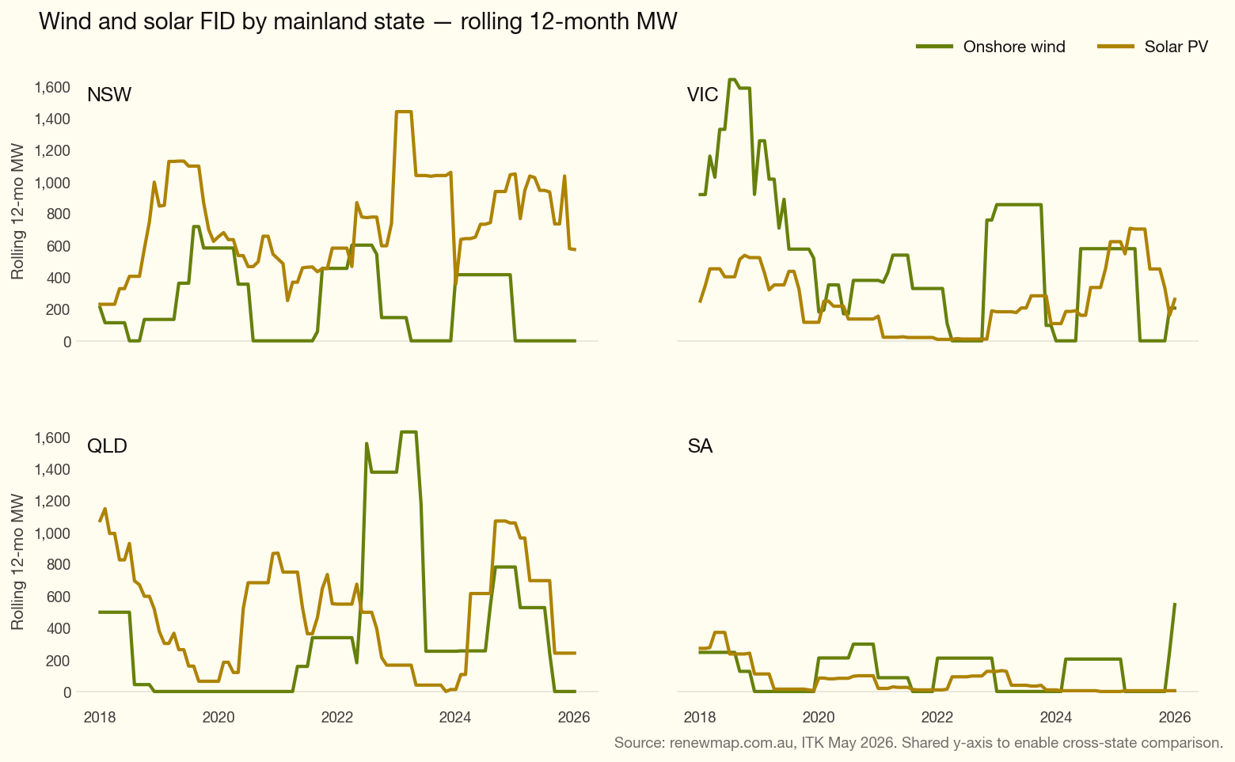
Figure 2: renewmap_fid_rolling12_by_state

Oversupply and low prices are a problem.
Electricity and gas prices in the spot market couldn’t be more different than in the immediate aftermath of Russia’s invasion of Ukraine. Spot electricity prices are down, and so are spot gas prices despite the difficulties Qatar has with exporting LNG through the Straits of Hormuz.
That’s occurred despite talk of lots more demand from smelters — with more ability to recover from death blows than Freddy Krueger — and from data centres.
Data centres and AI are shaping up as the next us-and-them issue.
The point to be made is that low prices are bad for new supply.
- Wind. Just not happening. Despite years of complaining about transmission being late and the risk it imposes, in fact the real risk is developers who want a high IRR for free. It’s increasingly likely that few — possibly no — major NSW wind farms will get to FID in 2026, just as none did in 2025. I guess ORG’s $300 m in investment in Yanco Delta does provide some incentive to get the money back. But the rest progress at a snail’s pace.
- Solar. Last year everyone wanted a hybrid project but without the solar. This year I’m not even sure they want the battery part.
- Average daily battery output is up well over 150% compared to a year ago, but margins are down. The fleet is bigger and busier, but each MWh dispatched earns less.

NEM Year to date outcomes
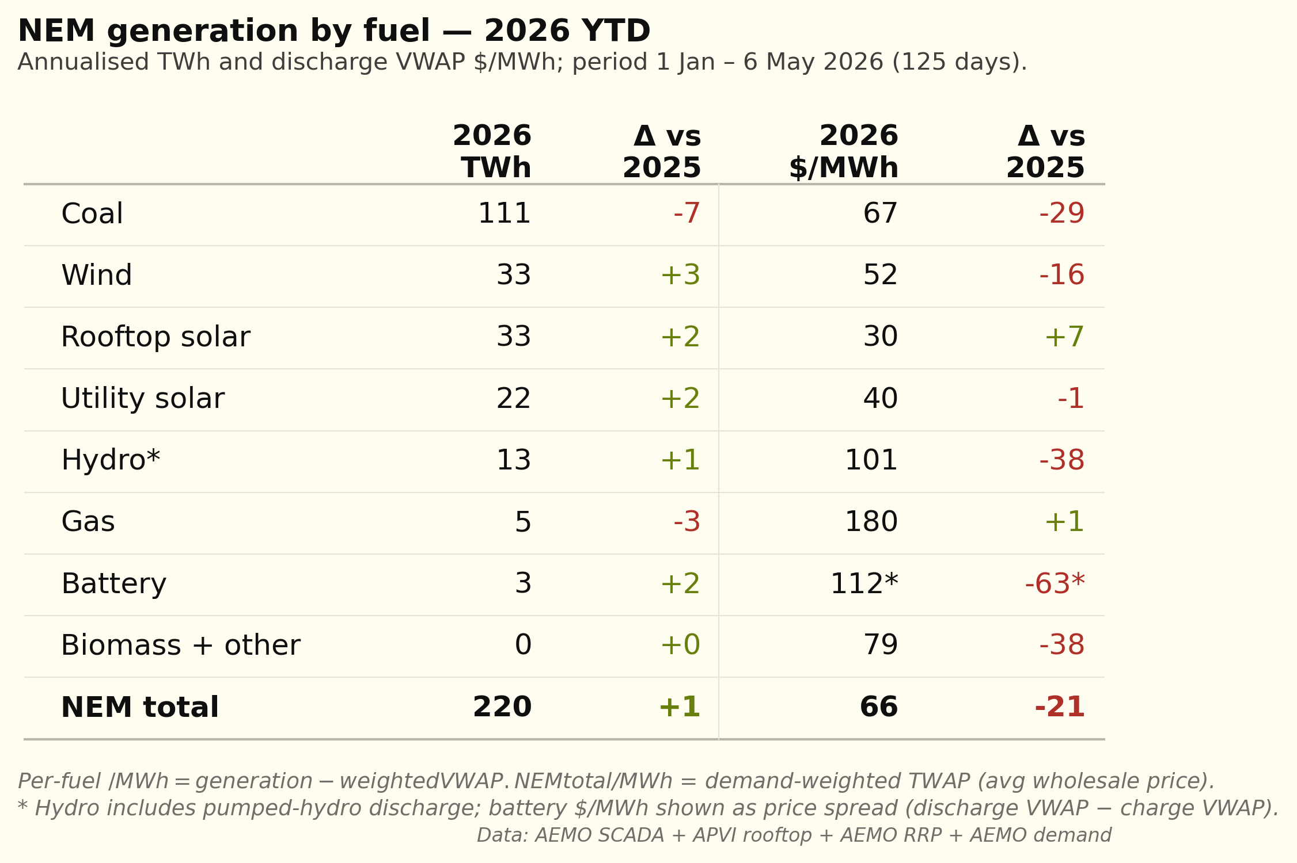
Figure 3: fuel_ytd_annualised_compact
If you are a consumer these are excellent numbers, but obviously they are only for a part of the year and don’t include Winter. Either of a wind drought or a major coal outage would push prices straight back up again.
Also of interest is that between utility batteries and household batteries there seems to be some impact on midday prices. So the storage is increasing midday prices very mildly but driving down peak prices much more and so overall prices come down.
However, that’s not the point. The point is that there is no price signal for new investment in these numbers. Not for anyone. The LCOE for wind is at least $100/MWh and I’m sure developers would say more.

Generators have to be subsidised through the transition
The transition window is at least ten years. Getting the timing right is impossible.
During the transition new supply will be operating at the same time as old supply that is due to exit. And it’s not one business with management setting a schedule. It’s all driven by spot market prices and competitive tensions. If we didn’t care about blackouts we could leave it all to the markets. Low prices would mean underinvestment, until something broke — a generator failure, a demand spike, an outage. Prices would spike, perhaps with energy shortages, and the Government would step in.
That’s the dumb way to do it.
The smart way is to accept that during the transition there will be oversupply keeping prices below that required for new investment and therefore consumers, via Government subsidy, need to (i) pay up to induce new supply and (ii) pay existing producers to keep producing.
State Governments are already paying existing producers, e.g. Yallourn and Eraring, to stay open but they aren’t paying up at the moment for the replacement supply.
Victoria has, in my opinion, mismanaged community relations forcing it to offshore wind when it actually has a perfectly adequate onshore resource. Anyone wanting to see how badly Victoria has stuffed up its community relations should read Eleanor Buckley and Bec Colvin’s just published piece. Although it’s not the point of the article, all of us in the industry will look at this plot and see the degree of difficulty. I am reminded again “a stitch in time saves nine”
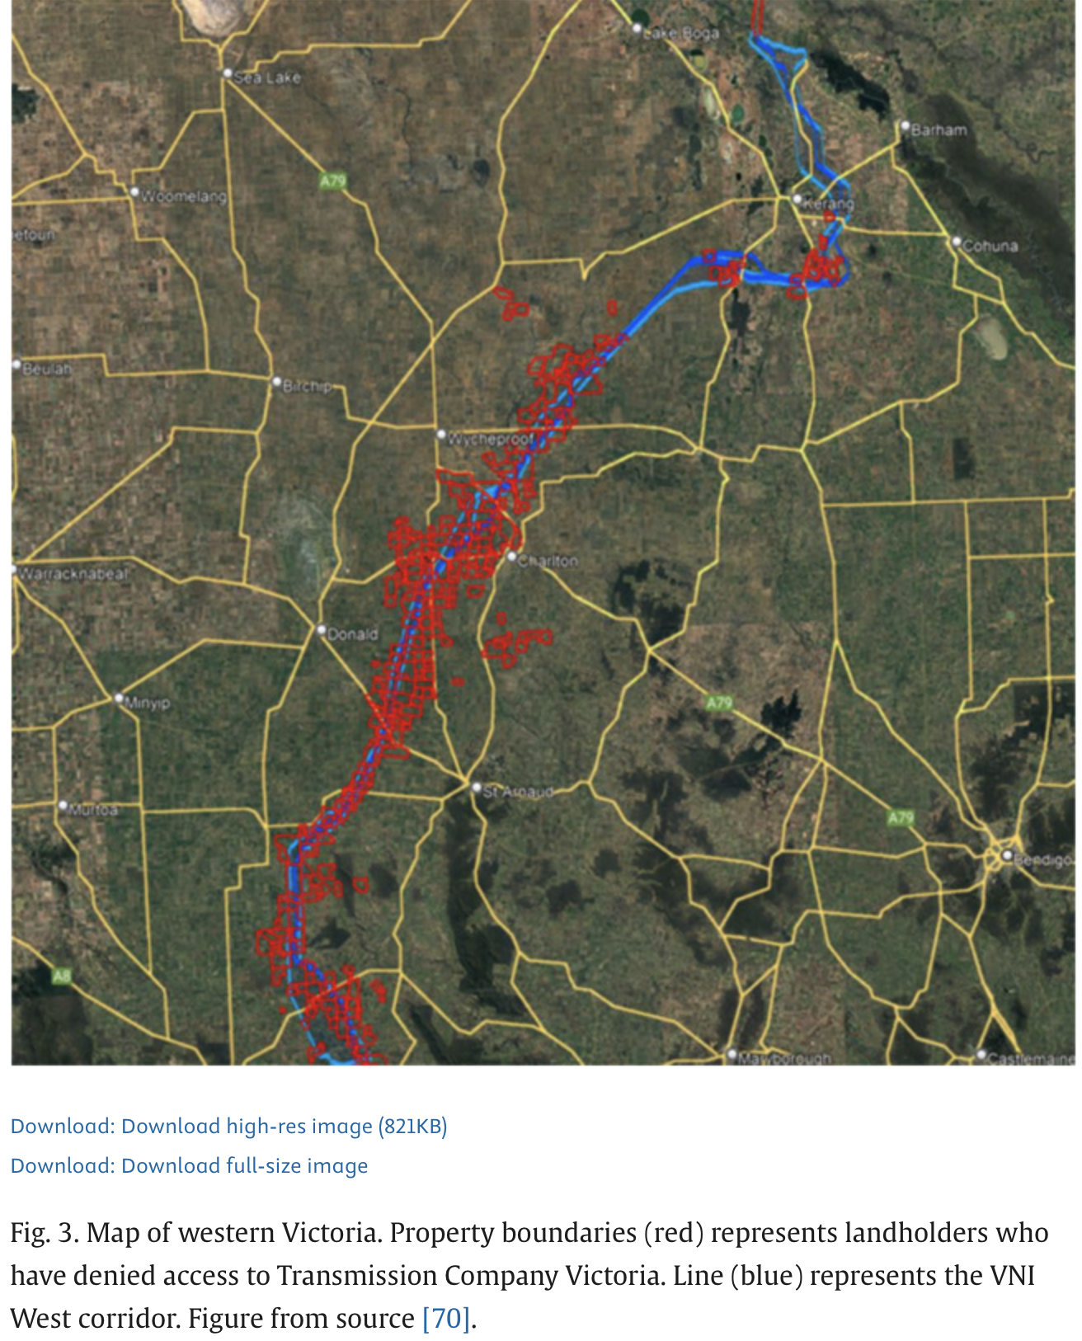
Figure 4: image-20260506102334783
NSW by contrast has managed to get its transmission to the point where it’s actually being built. But what it hasn’t done is get anyone to build any new capacity.
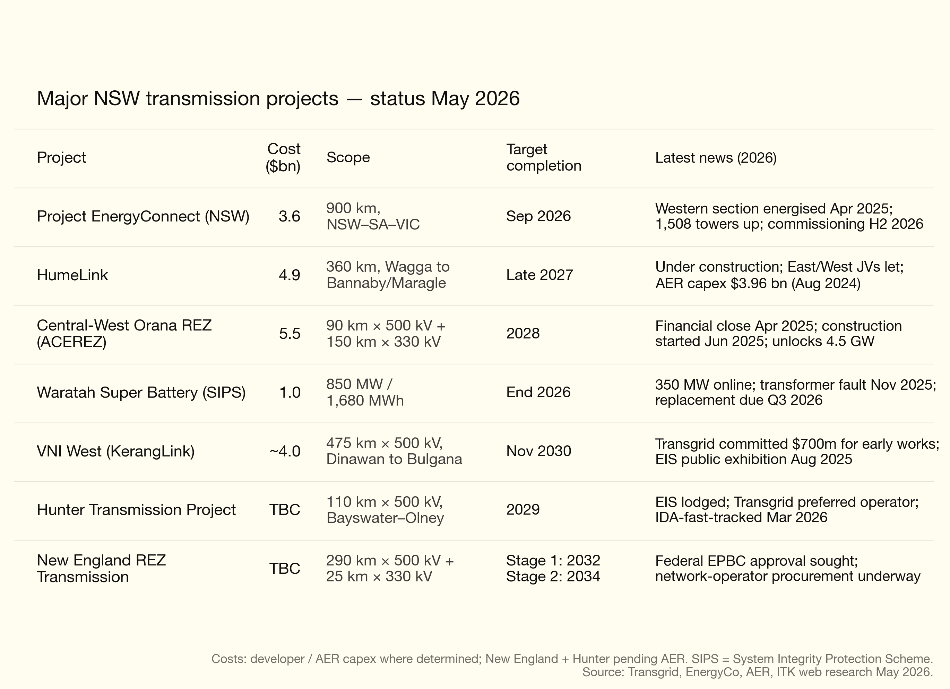
Figure 5: nsw_transmission_2026
At the moment it’s 50:50 at best whether any of the major wind projects in NSW will get to FID in calendar 2026.
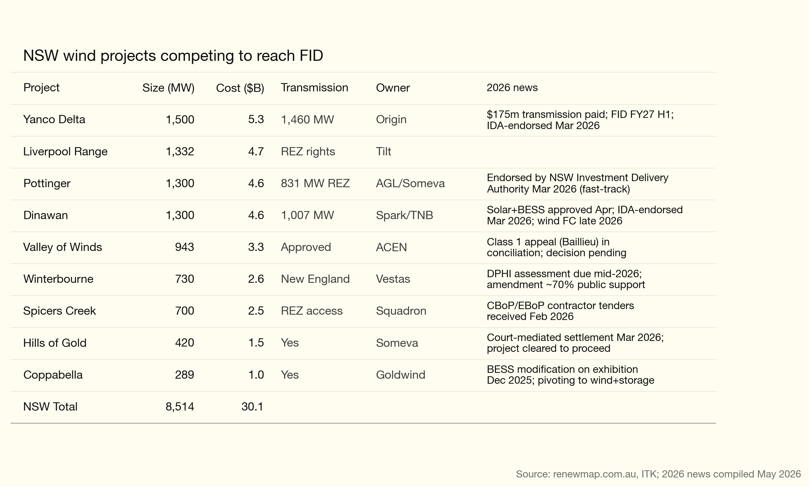
Figure 6: nsw_wind_projects_2026_news
Contrary to my previous note in late December the project seeming to have made the most progress is Spicers Creek. It’s good that one project is making visible progress in Orana because at this stage my bet is the transmission will be ready before the generation.
I’ve excluded Westwind’s far NSW project (Lake Victoria) notwithstanding that Westwind arguably has one of the best operating projects in the NEM and an outstanding construction record. I understand that Pottinger is hopeful of getting to FID this year but hope doesn’t keep the lights on. Piambong (Vestas 400 MW+) has received the NSW concierge service but its EIS is not yet on exhibition, with construction not expected until 2028 if it gets to FID.

Remaining new supply is limited
I just repost this from my last SOS
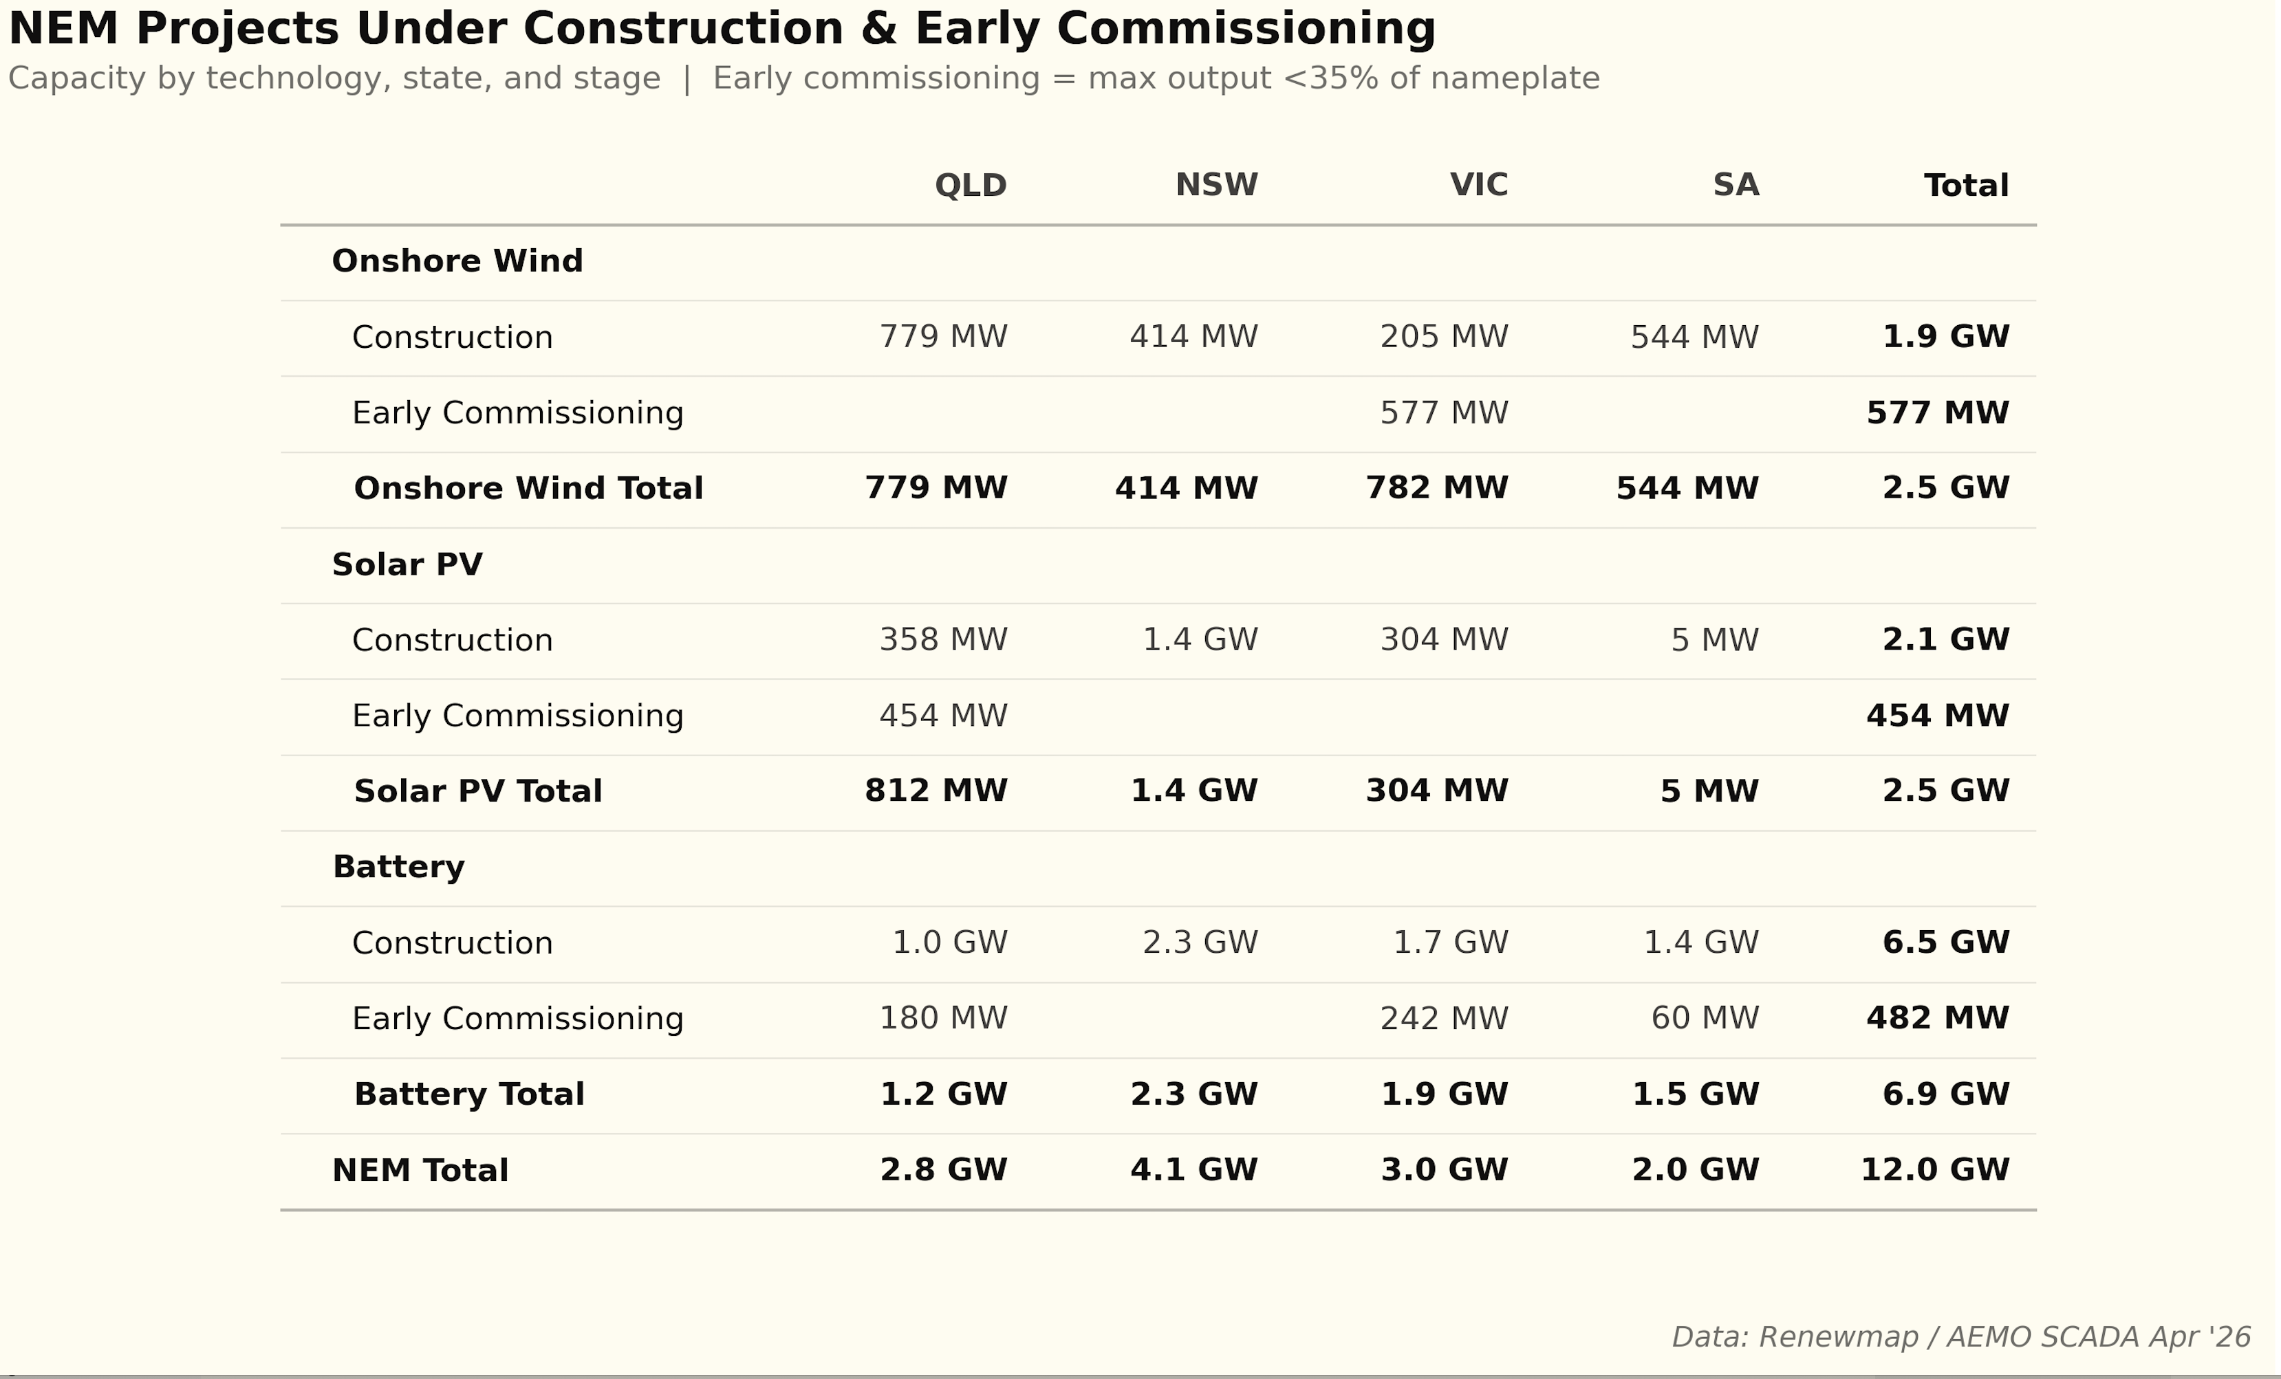
Figure 7: New supply - thanks Renewmap
We are down to just 4 GW of solar and wind projects that are in construction but not yet started commissioning. If I worked on, say, a 30% capacity factor, that’s maybe 12 TWh of energy. Plus some rooftop.
Even on what the industry would call optimistic price assumptions, the numbers don’t work: 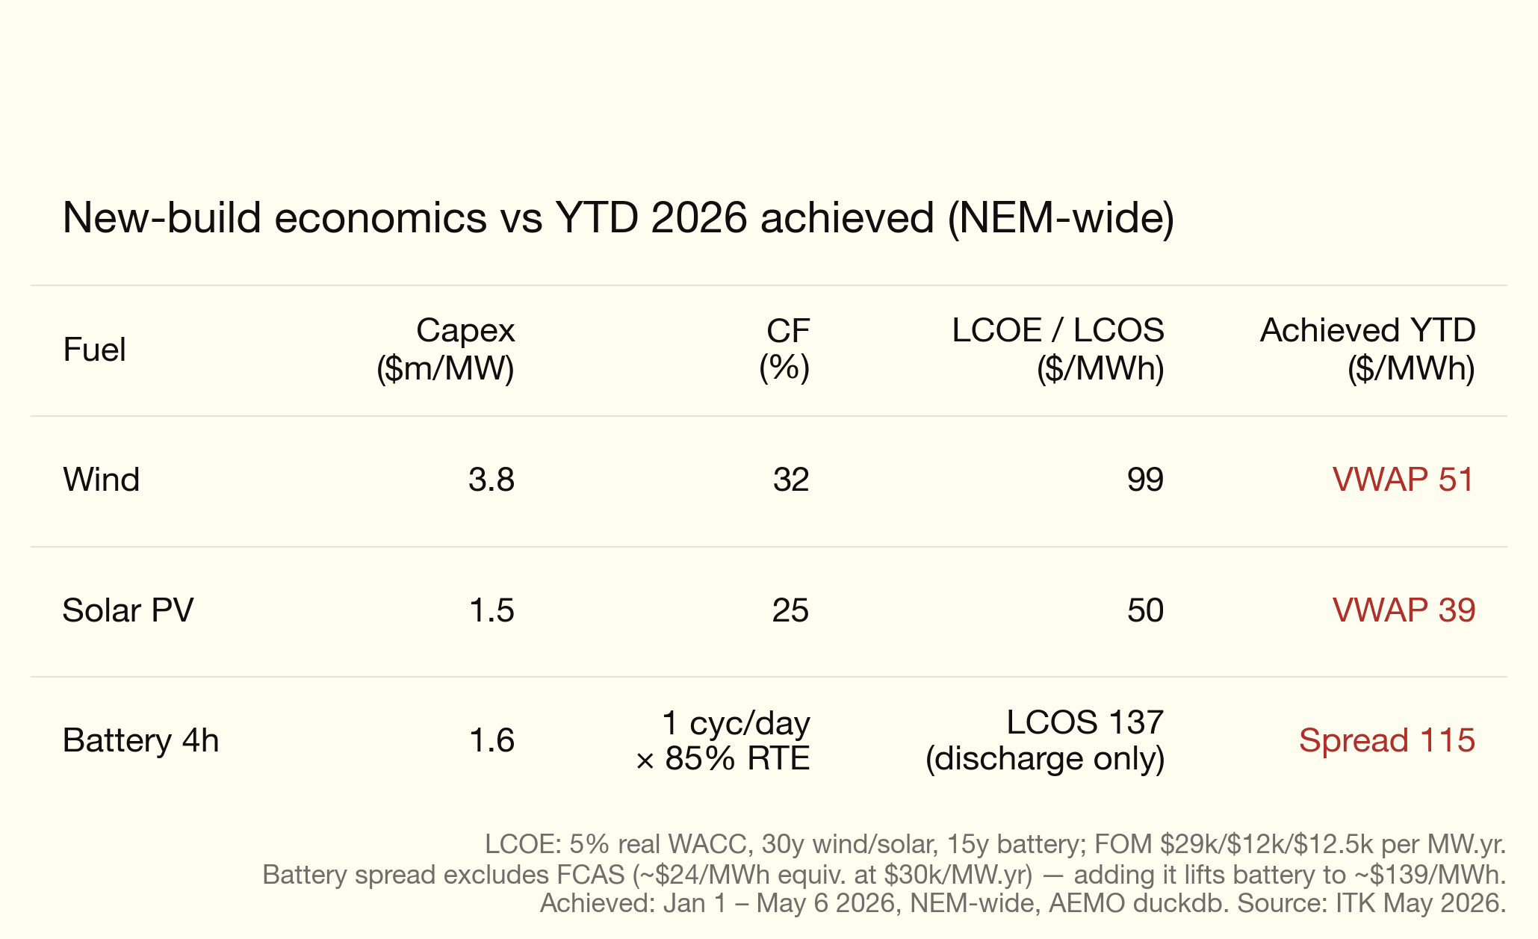
The above LCOE/LCOS used the following WACC calculations. 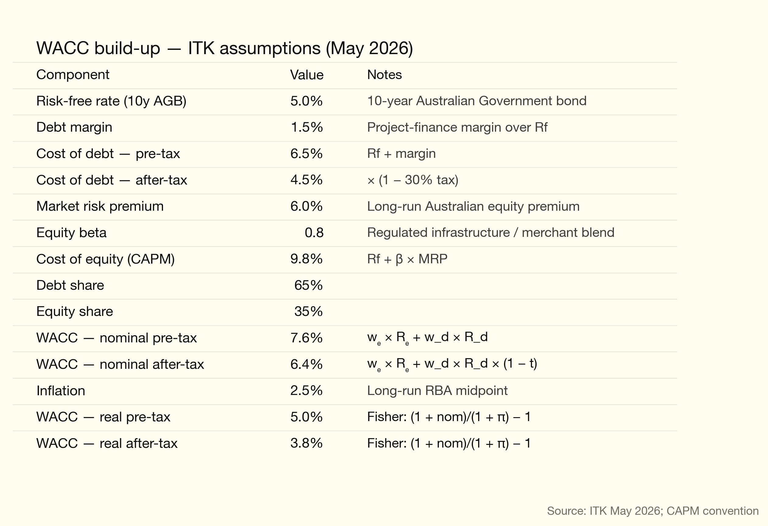
I don’t think the capex numbers are that wrong but the calculations don’t allow for curtailment or MLF. However you look at it, based on the part year to date estimates prices aren’t high enough.
I’d argue simple flat-swap PPAs — a la the ACT model — remain by far the best way to get stuff built. Reinventing the wheel with LTESA, CIS, or Tim Nelson’s ESEM is a mystery. KISS.

Dave’s solution
It’s almost certain now that, excluding a few batteries and some behind-the-meter solar, there is going to be at least a one-to-two year period where little, if any, new capacity will come online in the NEM.
The simplest way is to connect CIS awards to PPAs. Proponents who are able to hit FID this year can rebid their CIS as a flat swap PPA. Proponents who can hit FID in 2027 can bid their projects at a discounted flat swap PPA. Allocations: 2 GW wind and 2 GW solar this year, 4 GW of each in 2027, and another four of each in 2028. Penalties payable and PPAs cancelled for not starting construction in the specified time frame.
The lesson is always the same: simplify relentlessly. You want to buy a Tesla? Musk reduced the digital sales process from roughly 64 clicks down to about 10. Before that he shifted sales entirely online and fixed the price. This saved consumers money and sped up the entire process.

Bonus chart: Utility battery output build up
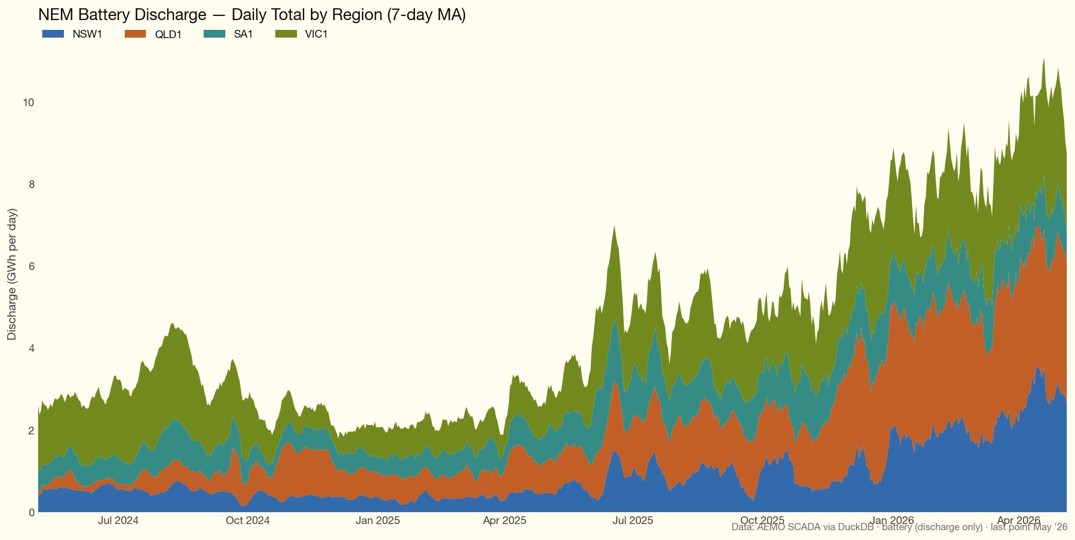
Figure 8: battery_discharge_nem_2yr

see “A nightmare on elm street”
like many an SOS will fall on deaf ears.

